Robert Allen Sprunger
May 27, 1961 – May 27, 1961

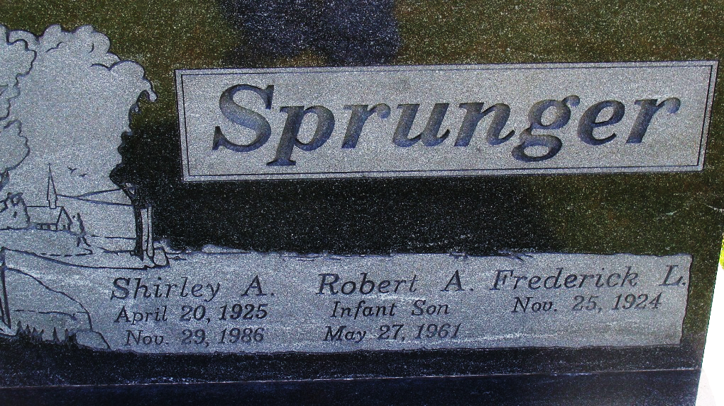
Photo by Alicia Kneuss

Web: Grant County, Indiana, U.S., Marion Public Library Death Index, 1812-2015

Name Robert A. Sprunger
Death Date 27 May 1961
Death Place Grant, Indiana, USA
Notes Death Records Indexed by Indiana Room Volunteers
Record Type Death
**

Robert Allen Sprunger from tree Marjorie's Families

Birth 27 May 1961 Marion, Grant, Indiana, USA
Death 27 May 1961 Marion, Grant, Indiana, USA
Father Frederick Lynn Sprunger (1924-2021)
Mother Shirley Joan Schug (1925-1986)
6582 People 3 Records 3 Sources

