Coleen R. (Schindler) Sprunger-Rich
March 3, 1929 – October 11, 2009

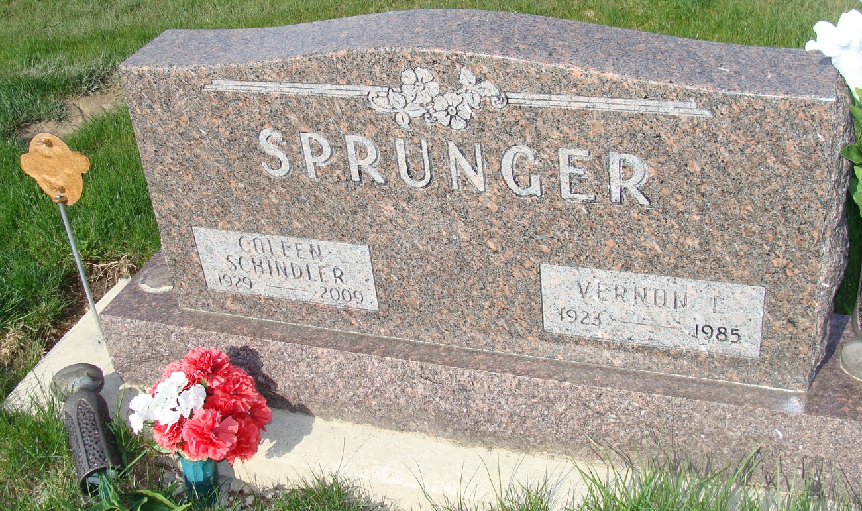
Photo by Alicia Kneuss

Coleen R. Sprunger-Rich, 80, of Berne, Indiana passed away at 12.01 a.m. Sunday, October 11, 2009 at Parkview Hospital in Fort Wayne, Indiana. Coleen was born on March 3, 1929 in Adams County, Indiana the daughter of Floyd and Edna (Beer) Schindler, both deceased. She married Vernon Sprunger on July 8, 1947 and he preceded her in death 1985. She married Denver Rich on November 5, 1988 and he survives.
Coleen was a member of the Grace Bible Church in Berne, Indiana where she was a Sunday school teacher, a member of the church choir, a former member of the Dorcas Circle, and a present member of the Ladies Fellowship. Coleen was a former employee of Dr. F.F. Sprunger D.D.S., and Dr. Scott Lehman, and was the present bookkeeper for the Berne 66 Service Center. Coleen's special interests included caring for birds, with the Cardinal being her favorite, playing Canasta, and enjoying her flowers.
Coleen is survived by her husband, Denver Rich, of Berne, Indiana; a son, Allen (Gwen) Sprunger of Berne, Indiana; a daughter, Sandra J. (Dennis) Williams of Decatur, Indiana; a step-son, Harry (Nelda) Rich of Bluffton, Indiana' a step-son, James Rich of Berne, Indiana; a step-daughter, Mary (Bob) Van Cleave of Angola, Indiana; a step-daughter, Betty (Jim) Menzie of Fort Wayne, Indiana; and a sister, Imogene Moser of Tucson, Arizona. Other survivors include ten step-grandchildren and eighteen step-great- grandchildren. Coleen was preceded in death by her first husband, Vernon Sprunger, and a step son, John Rich.
Funeral services will be held at 10:00 a.m. Wednesday, October 14, 2009 at the Grace Bible Church in Berne, Indiana with the Rev. Chuck Circle officiating. Interment will be in the M.R.E. Cemetery of rural Berne, Indiana. Family and friends will be received from 2:00 – 8:00 p.m. Tuesday, October 13, 2009 in the Yager-Kirchhofer Funeral Home in Berne, Indiana and one hour prior to the funeral service at the church on Wednesday.
Preferred memorials are to the Grace Bible Church.
**
Indiana, U.S., Death Certificates, 1899-2017
Name Coleen R Sprunger Rich
Maiden Name Schindler
Gender Female
Race White
Age 80
Marital Status Married
Birth Date 3 Mar 1929
Birth Place Adams County, Indiana
Death Date 11 Oct 2009
Death Place Fort Wayne, Allen, Indiana, USA
Death Registration Date 2009
Father Floyd Schindler
Mother Edna Beer
Spouse Denver Rich, informant
Burial M.R.E. Cemetery, no date

