Regina (Moser) Sprunger
May 12, 1847 – July 19, 1908

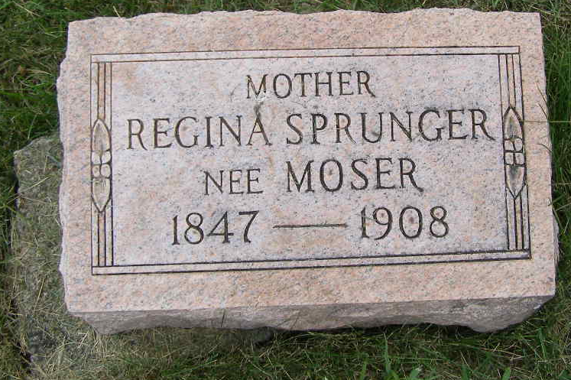
Photo by Shaunda Bedwell Opdycke

Indiana, U.S., Death Certificates, 1899-2017
Name Regina Sprunger (indexed as Spangler)
[Regina Mosser]
[Regina Sprunger]
Maiden Name
[Moser]
Gender Female
Race White
Marital Status Married
Age 61y 2m 7d
Birth Date 12 May 1847
Birth Place Switzerland
Death Date 19 Jul 1908
Death Place Berne, Adams, Indiana, USA
Death Registration Date 1908
Father Chris Mosser b. Switzerland
Mother Elizabeth Nussbaum b. Switzerland
Spouse David Spangler b. Switzerland, informant
Burial M.R.E. Cem. 7/21/1908
**

U.S., Family History Books

The Sprunger Family by W. E. Herr, p. 161
4.11 David Sprunger 7-5-1836 - 12/25/1916
David was born in Tavannes, Switzerland and was married Jan. 1, 1857 to Barbara Lehman, daughter of Johann from Wayne Co., O. She was born Jan. 1, 1833. They lived near Berne, Ind. where she died Aug. 3, 1874. On Aug. 3, 1876 he married Regina Moser, daughter of Christian. David was a farmer and forkmaker. Regina was born May 12, 1847 and died July 19, 1908.

