Raymond Emanuel Sprunger
November 1, 1913 – July 30, 2001

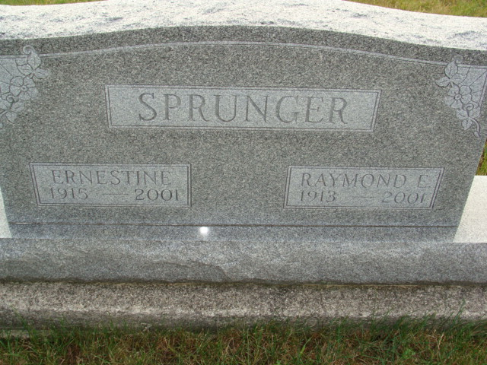
Photo by Alicia Kneuss

Raymond E. Sprunger, 87, of Berne, who retired from Dunbar Furniture after 40 years of service, died Monday, July 30, 2001, at Swiss Village. The Adams County native was a member of Grace Bible Church, where he served as a custodian for 20 years and was a member of board of deacons.
Surviving are his wife, Ernestine E.; a daughter, Sherryll A. Sprunger of Berne; and sisters Helen Beer, Ada M. Frank and Marjorie Von Gunten, all of Berne. He was preceded in death by a brother,
Millard.
Services are 10:30 a.m. Thursday at Grace Bible Church, Berne, with calling one hour before services. Calling is also from 3 to 8 p.m. today at Swiss Village, Berne. Burial will be at MRE Cemetery, Berne.
Memorials are to the church Missions, Gideons International or Mission to the Americans.
Information provided by Yager-Kirchhofer Funeral Home, Berne, 1-219-589-3101.

News-Sentinel, The (Allen County, Indiana)
Wednesday, August 1, 2001
**

Indiana, U.S., Death Certificates, 1899-2017

Name Raymond E Sprunger
Gender Male
Race White
Marital Status Married
Age 87
Birth Date 1 Nov 1913
Birth Place Adams County
Death Date 30 Jul 2001
Death Place Berne, Adams, Indiana, USA
Death Registration Date 2001
Father Rufus Sprunger
Mother Cora Luginbill
Spouse Ernestine E (Liechty) Sprunger, informant
Burial 8/2/2001 M.R.E.
**

Indiana, U.S., Marriages, 1810-2001

Name Raymond E Sprunger
Gender Male
Race White
Age 28
Event Type Marriage Registration (Marriage)
Birth Date 1 Nov 1913
Birth Place Monroe, Indiana
Marriage Date 12 Apr 1941
Marriage Place Berne, Indiana, United States
Residence Place Berne, Indiana
Father Rufus Sprunger
Mother Cora Luginbill
Spouse Ernestine Elizabeth Liechty
Page 198
FHL Film Number 002321634

