Rachel R. (Sprunger) Sprunger
March 27, 1859 – August 19, 1924

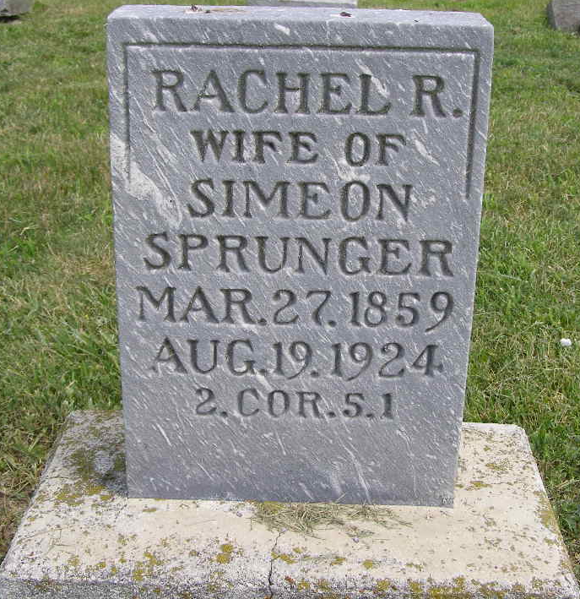
Photo by Shaunda Bedwell Opdycke

Indiana, U.S., Death Certificates, 1899-2017

Name Rachel R Sprunger
Maiden Name Springer
Gender Female
Race White
Marital Status Married
Age 65y 5m 22d
Birth Date 27 Mar 1859
Birth Place Canton Bern Switzerland
Death Date 19 Aug 1924
Death Place Monroe, Indiana, USA
Death Registration Date 1924
Father Peter R Sprunger b. Switzerland
Mother Katherine Reusser b. Switzerland
Spouse Simeon Sprunger, informant
Burial MRE Cemetery 8/22/1924

