Powell Leon Sprunger
November 12, 1939 – June 5, 2004

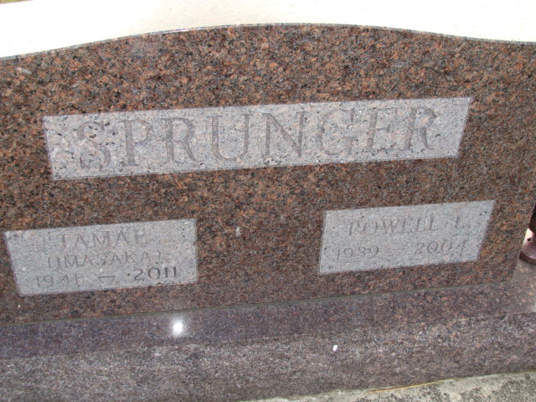
Photo by Alicia Kneuss

Powell L. Sprunger, 64, of Celina, died at 2:35 p.m. June 5, 2004, at Mercer County Community Hospital, Coldwater. Death was due to natural causes. He was born Nov. 12, 1939, in Adams County, Ind., to Lowell and Nellie Jones Sprunger.
His wife, the former Tamae Imasaka, survives. Also surviving are a son, Rene T. of North Branford, Conn.; and two brothers, Michael of Leamington, Utah, and Melville of Phoenix.
He was a patent lawyer and the author of seven mathematics books. He graduated from Purdue University and the University of Southern California Law School.
Services are 11:30 a.m. Wednesday at Yager-Kirchhofer Funeral Home, Berne, Ind., the Rev. Harold Nussbaum officiating. Burial will follow at M.R.E. Cemetery, Berne. Calling is after 9 a.m. Wednesday at the funeral home. Contributions can be made to the First Mennonite Church Missions.

The Daily Standard, Mercer County, Ohio

