Philipp Sprunger
August 6, 1858 – May 13, 1934

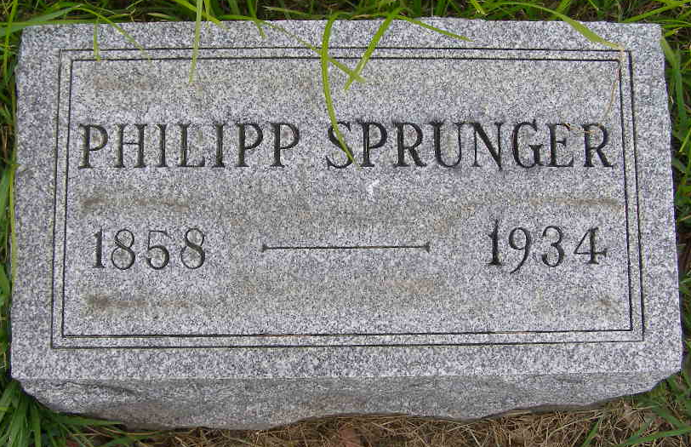
Photo by Shaunda Bedwell Opdycke

DEATH TAKES P. SPRUNGER HERE SUNDAY
Philip Sprunger, 75, Dies at Home on North Jefferson Street FUNERAL IS TUESDAY P.M.

Philip Sprunger, aged 75, well known local man and formerly a prominent carpenter, passed away at his home on North Jefferson street Sunday afternoon at 2:25 o'clock. Death was caused by nephritis, dropsy and complications. Mr. Sprunger had been sick since Thanksgiving and suffered several heart attacks since then, but always rallied. Several days ago he appeared to have contracted pneumonia, but this disease was checked. He became weaker every day, however, until Sunday when he passed peacefully away.
The deceased was born in Berne, in the house now occupied by the Dr. Amos Reusser family, on August 6, 1858, a son of Peter and Maryann Moser Sprunger. He was 75 years, nine months and seven days old at the time of his death. When he was born little of the present town was here at that time and his father owned much of the land around what is now the Dr. Reusser property.
Mr. Sprunger spent all his life in Berne with the exception of a few years when he lived a short distance west of town. He was a carpenter most of his life and was supervisor of a gang of carpenters for many years. He kept active in his works (paper crease)
...Surviving are the following children: Mrs. William (Phillipine) Norr of Wabash twp.; Mrs. Menas (Pauline) Wulliman of northwest of Berne; Robert, Monroe; Mrs. Leon (Hilda) (paper crease)
...The following children preceded him: Mrs. C. W. R. Schwartz, and Edward, Marcus and Otto died in infancy. Three brothers preceded, Christian, Peter and Daniel Sprunger. (paper crease)
...Before his death he requested that friends omit flowers for his funeral and that if they have any money to share, they should give it to the needy. The funeral will be held Tuesday afternoon at 1:30 at the home and 2 o'clock at the Mennonite Church, Rev. C. H. Suckau officiating. Interment will be in the MRE Cemetery.

Adams County Historical Museum
1934 Scrapbook, image 052
Handwritten date: Monday, May 14, 1934

