Petter R. Sprunger
May 8, 1824 – June 23, 1903

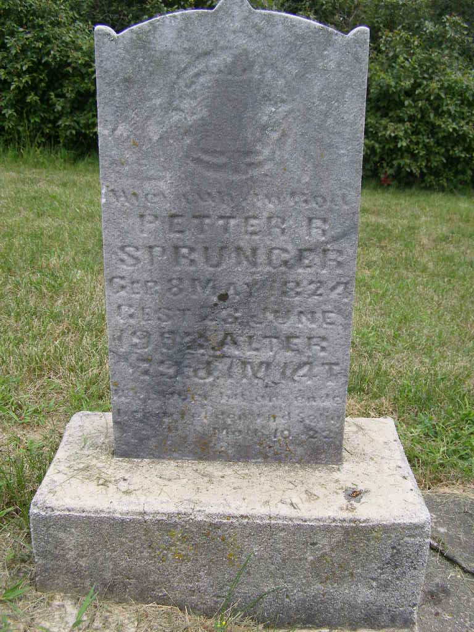
Photo by Shaunda Bedwell Opdycke

Indiana, Death Certificates, 1899-2011
Name: Peter R Sprenger
Gender: Male
Race: White
Age: 79y 1m 15d
Marital status: Widowed
Birth Date: 8 May 1824
Birth Place: Swiss
Death Date: 23 Jun 1903
Death Place: Monroe Township, Adams, Indiana, USA
Death Registration Date: 1903
Father: Chr. Sprunger
Mother: Anna Lehmann
Informant: Simon Sprunger; Berne, Indiana
Burial: June 25, 1903; MRE Cemetery

