Peter R. Sprunger
January 28, 1825 – November 12, 1898

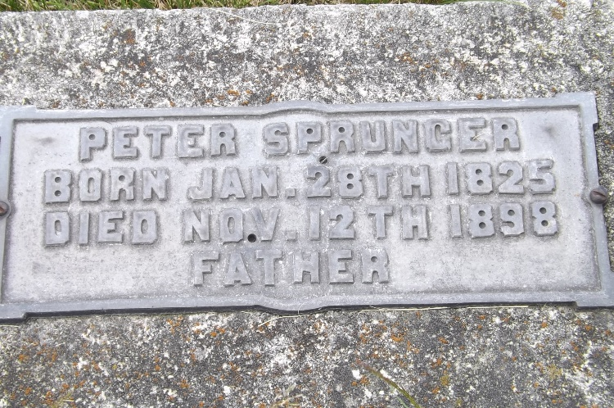
Photo by Jim Allen

PETER SPRUNGER
One of the Earliest Settlers in Berne Passed Away

Peter Sprunger, one of Berne’s oldest citizens, who traversed this spot long before it had the appearance of village or could be called a town, who had seen this place grow wild forest into a well and neatly built little town with all its churches and factories and brick blocks, died at his home in Berne after four weeks’ illness on Saturday evening, November 12, 1898, at the advanced age of 73 years, 10 months, and 15 days.
He was born on Muensterberg, Canton Bern, Switzerland, January 28, 1825, where he early united with the Mennonite church, his parents having adhered to the same confession of faith. On November 20, 1851, he became united in marriage to Mary Ann Moser, and in the spring of the following year they with a number of relatives and other members of their church immigrated into this county settling down on the very piece of land on which he died, and his wife four years ago.
During the 13 years they lived together they became the parents of nine children, seven of whom survive them, and were grandparents to 43 children of whom 37 are still living. He is also survived by two brothers and two sisters. His nephews and nieces and grand-nephews and grand-nieces and other relatives number several hundred.
The funeral was largely attended on Monday afternoon at his home where Rev. Peter M. Neuenschwander held a brief service, and at the Mennonite church where his brother Rev. S. F. Sprunger, assisted by Rev. Peter E. Lehman, brother-in-law of the deceased, conducted the funeral services, Rev. B. Ruf reading the first chapter of the first epistle by St. Peter, and Rev. C. R. Egle leading in the opening prayer. Interment took place in the M. R. E. cemetery.

The Berne Witness, Adams County, Indiana
Thursday, November 17, 1898

