Peter Edison Sprunger
November 11, 1899 – July 11, 1942

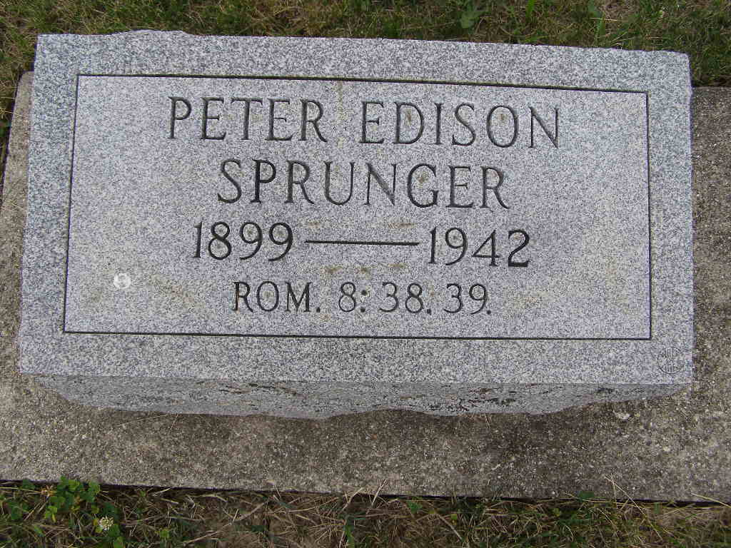
Photo by Shaunda Bedwell Opdycke

Peter Edison Sprunger Rites Held Here This Afternoon
Local High School Teacher for 20 years Hangs Self at Home Here Saturday Morning Had Been in Ill Health for Several Months
Son Finds Body

The funeral service was held here this afternoon with Rev. Alfred Clauser officiating in the absence of Dr. C. H. Suckau, pastor of the church. He was assisted by Rev. Simon Beck of Leo. Burial was in the M.R.E. Cemetery. Music was furnished by the Mennonite Men’s Chorus. The pallbearers were six members of the local high school faculty, Supt. E. M. Webb, William Spurgeon, Maynard Hetrick, Lake Glendening, Freeman Burkhalter and J. D. R. Schwartz.
Mr. Sprunger’s untimely death came as a great shock to the people of Berne and community and to the members of his own family especially. He had been around the house on Saturday morning and when Mrs. Sprunger missed him, she sent their older son, Kenyon Lee, 8, to look for him. He found him in the basement and hurried back to notify his mother. The lad then ran over to the Arthur Zehr home, next door neighbor to the Sprunger’s, who hurried into the basement at the boy’s frantic appeal for help.
Mr. Sprunger committed the act in the furnace room of the basement. He had used his belt to fashion a noose around his neck. The other end was attached to a cross piece between the joists of the ceiling. He had apparently stepped on a box about six inches high and then kicked the box out from under him. His shoes were a bare few inches above the floor. Mr. Sprunger had a work bench in the basement and he is reported to have remarked to a member of the family that he was going into the basement for a few minutes. It is reported that he was not out of sight more than 15 minutes.
The body was cut down by Mr. Zehr. He used his pocket knife to cut the belt in two. Mr. Zehr said that life was apparently gone when he came to the scene. A local doctor was notified at once. He pronounced him dead and said that artificial respiration would have been of no avail as heart action had stopped. This statement was verified by Coroner J. Jerome Yager.
He was married to Viola Schlatter on August 5, 1927. To this union were born three sons, Stanley Keith (cut off)
Decatur Daily Democrat, Adams County, Indiana
July 13, 1942
**

Indiana, U.S., Death Certificates, 1899-2017

Name Peter Edison Sprunger
Gender Male
Race White
Marital Status Married
Age 42y 8m 0d
Birth Date 11 Nov 1899
Birth Place Berne Adams, Indiana
Death Date 11 Jul 1942
Death Place Berne, Adams, Indiana, USA
Death Registration Date 1942
Father Benjamine Sprunger, informant
Mother Susan Burkhalter
Spouse Viola Schlatter Sprunger, age 38
Burial 7/13/1942 M.R.E. Cemetery

