Peter E. Sprunger
February 27, 1820 – September 10, 1904

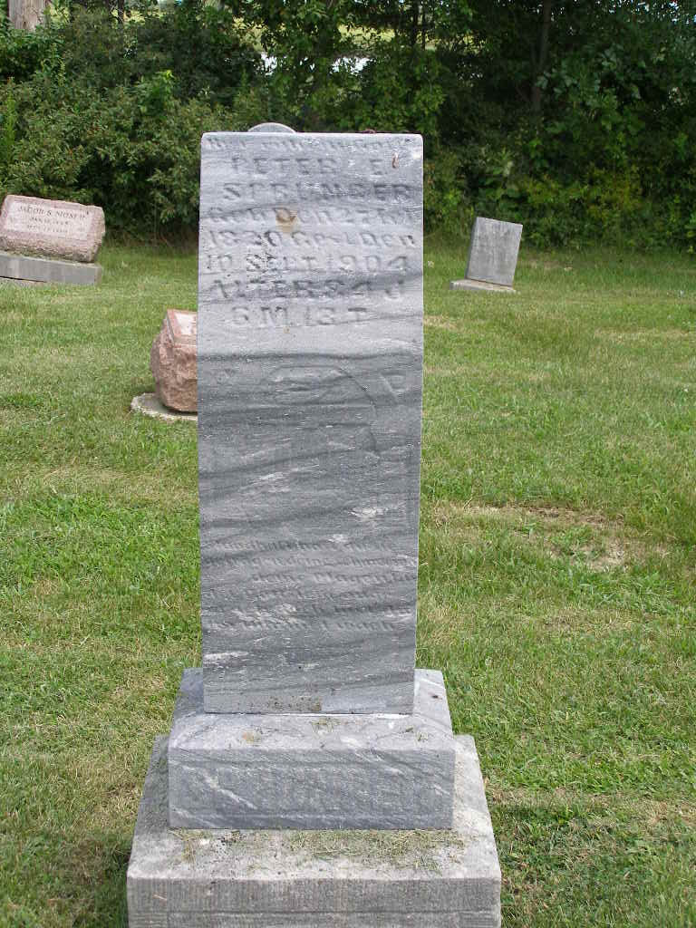
Photos by Shaunda Bedwell Opdycke
Grandpa Peter E. Sprunger, after suffering considerably for ten years and quite severely during several days preceeding his death, quietly and peacefully passed from this into a better world at his home
Saturday forenoon at about twenty minutes past eleven o'clock.
Although from his thirtieth year on, he had been suffering somewhat from kidney trouble, he reached the ripe, old age of 84 years, 6 months and 14 days. His trials and afflictions were many in his earlier days as well as during his later years, but he was always patient and contented up to the time he was released from his suffering.
Peter E. Sprunger was born February 27, 1820, in Latan, Dachsfeldenberg, Switzerland, where he was married in March of 1841 to Barbara Zuercher, she being thirteen years his senior. Four children, two sons and two daughters, were born to them. Peter spent many of his earlier days both in this and in the old country at his father's, the Weaver's trade. He wove all the clothing for the family.
He with his family was among the 82 immigrants that came to America in 1852 who in April, 1902, celebrated the 50th anniversary of their landing at the Mennonite church here. For three years the family made their home with David Zuercher's in Wayne Co., Ohio, after which they moved to Berne, locating on the farm where the deceased lived to his end.
He was preceeded in death by his wife who died 16 years ago and by three children, three brothers and six sisters. Two brothers, Johannes and David, one daughter, Mrs. Jacob Sprunger, 38 grand-children and 24 great-grandchildren remain to mourn their loss.
The funeral took place yesterday afternoon from the Mennonite church. Services were held in the house at 1:30 and at 2 o'clock at the church. Burial took place in the M. R. E. cemetery.
Berne Witness, Adams County, Indiana
September 13, 1904
**

Indiana, U.S., Death Certificates, 1899-2017

Name Peter E Sprunger
Gender Male
Race White
Marital Status Married
Age 84y 6m 13d
Birth Date 27 Feb 1820
Birth Place Switzerland, Easton Berne
[Switzerland (Canton Berne)]
Death Date 10 Sep 1904
Death Place Monroe, Adams, Indiana, USA
Death Registration Date 1904
Father John Sprunger
Mother unknown
Spouse Barbara Sprunger
Informant A. A. Sprunger, Berne, IN
Burial M.R.E. Cem Mon., 9/12/1904

