Peter A. Sprunger, MD
October 23, 1839 – November 8, 1885

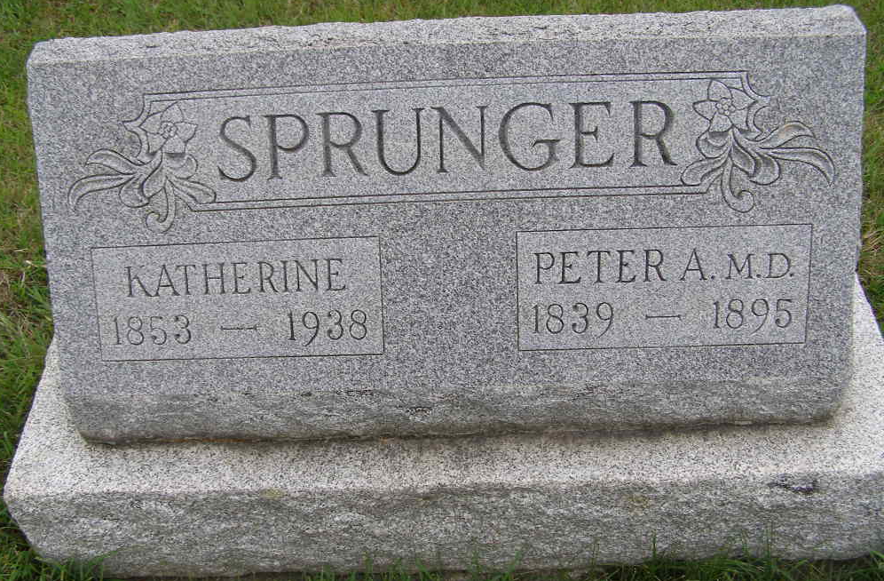
Photo by Shaunda Bedwell Opdycke

Berne Items

Dr. P. A. Sprunger, who resided about two miles northeast of Berne, was found dead in front of his barn on Friday morning Nov. 8th. The doctor was out visiting patients the evening before and seemed to be in perfect health. The deceased was fifty-six years of age and very highly respected. Appoplexy (sic) was the cause of his sudden death. He leaves a wife and fourteen children and an aged father to mourn their loss. The funeral took place Sunday morning at the Mennonite church and about two thousand attended the funeral.

Decatur Democrat Press, Adams County, Indiana
November 14, 1895
**

DR. PETER A. SPRUNGER, homoeopathic physician, residing at Berne, Adams County, is a native of Switzerland, born October 23, 1839, a son of Abraham B. Sprunger. He lived in his native country until fourteen years of age, when he came with his parents to the United States, and after stopping a short time in Ohio came to Adams County, Indiana. Peter A. was reared to the avocation of farmer, and received his education in the common schools of his native country, and after coming to America attended the schools of his district. He subsequently engaged in teaching school, which he followed twelve years, becoming a successful and popular instructor.
At the age of eighteen years he began the study of medicine under the preceptorship of Rev. Dr. Daniel Neuenschwander, of Berne, Indiana, and for about twelve years has been engaged in the practice of medicine. The doctor has a large practice, especially among citizens of his own nationality, and is noted for the reasonableness of his charges. He is well skilled in the knowledge of his profession, and is widely known and respected throughout the community where he resides.
Dr. Sprunger was first married November 22, 1862, to Catherine Amstutz, who was born in Switzerland, March 10, 1844. She died August 24, 1869, leaving two children - Dinah, who was born March 15, 1864, and died June 1, 1884, and William J., who was born October 17, 1867. The doctor was again married December 28, 1871, to Miss Catherine Sprunger, a native of Adams County, Indiana, born November 8, 1853, and to this union have been born nine children - Bertha, born May 28, 1874; Reuben, born October 27, 1875; Ann E., born January 20, 1877, died November 11, 1879; Jeremiah, born August 9, 1878; Rosina, born November 27, 1879; Christina, born February 3, 1881; Jonas, born October 13, 1882; Ernest, born August 6, 1884 and Elmer, born September 30, 1886. The doctor and his family are members of the Mennonite church.

Biographical and Historical Record - Adams and Wells Co. Indiana Lewis Publishing Co. Chicago, IL, 1887

