Peter Sprunger
November 20, 1867 – December 3, 1869

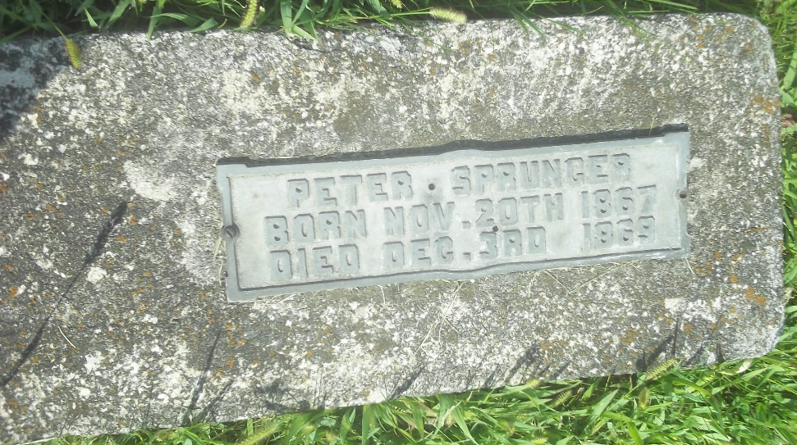
Photo by DSON1492

U.S., Family History Books
Name Peter
Birth Date 20 Nov 1867
Marriage Date 3 Dec 1869
Father Peter Sprunger
Mother Marianna Moser
Title The Sprunger Family, 1757-1972: in Three Parts From Manuscripts, p. 26
6. Peter Sprunger born January 28, 1825 on the Munsterberg, Switzerland, married November 29, 1851 to Marianna Moser. In 1852 they came to America to Adams County, Indiana. They bought a piece of woodland and built themselves a home where a part of the city of Berne now stands.
Children
Anna b. Sept. 1, 1852 m. Emanuel J. Lichty
Christian b. Oct. 25, 1853 d. Dec. 18, 1856
Emanuel b. Nov. 15, 1854 m. Katharina Stauffer
Daniel b. March 14, 1857
Phillip b. Aug. 6, 1858 m. Anna Lehman
Christian b. Sept. 11, 1860 m. Rosina Reusser
Marianna b. Sept. 14, 1863 m. Daniel Stuckey
Peter b. Nov. 20, 1867 d. Dec. 3, 1868
Benjamin b. Dec. 26, 1875

