Otto Franklin Sprunger
September 23, 1885 – August 10, 1953

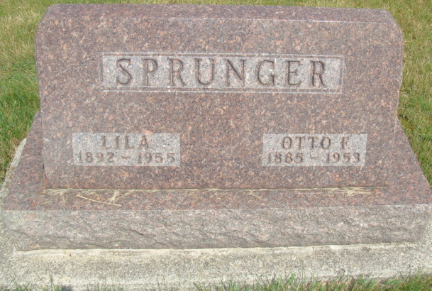
Photo by Alicia Kneuss

Indiana, U.S., Marriage Certificates, 1960-2012

Name Otto F Sprunger
Gender Male
Race White
Marriage Age 31
Birth Date 23 Sep 1885
Birth Place Berne, Adams, Indiana
Marriage License Date 23 Dec 1916
Marriage Date 24 Dec 1916
Marriage Place Adams, Indiana, USA
Residence Place Berne, Indiana
Father Frederick Sprunger
Mother Katherina Sprunger
Spouse Lila Lehman
Officiator P R Schroeder
**

Otto Franklin Sprunger from tree Field - Gephart Family

Birth 23 Sep 1885 Monroe City, Adams, Indiana, USA
Marriage 24 Dec 1916 Berne, Adams, Indiana, USA
Residence 1930 Bluffton, Wells, Indiana, USA
Death 10 Aug 1953 Bluffton, Wells, Indiana, USA
Father Friedrich A Sprunger (1849-1914)
Mother Katharina Sprunger (1854-1929)
Spouse Lila Lehman (1892-1955)
52829 People 8 Records 13 Sources

