Ottilia (Sprunger) Sprunger
August 23, 1885 – June 15, 1970

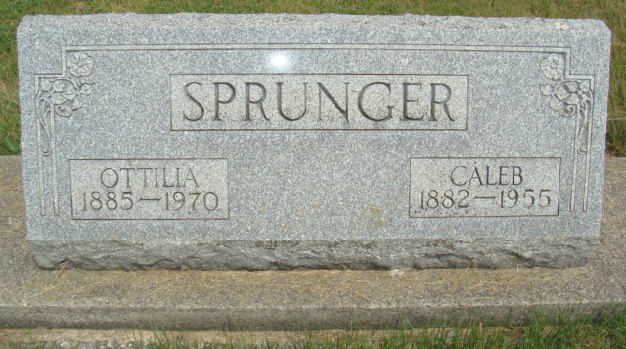
Photo by Alicia Kneuss

Ottilia Sprunger is taken by death
Mrs. Ottilia Sprunger, 84, widow of Caleb Sprunger, a resident of Swiss Village Retirement Home, died at the home at 3:10 p.m. Monday. She had been seriously ill since April 2.
She was born in Berne Aug. 23, 1885, a daughter of Emanuel and Katherine Stauffer-Sprunger, and was married to Caleb Sprunger Dec. 21, 1905. Her husband preceded her in death in June of 1955. Mrs. Sprunger was a member of the First Mennonite Church.
Surviving are three daughters, Mrs. Charles (Bernice) Bell of Fort Wayne, Mrs. Wilbur (Laura) Kirchhofer and Mrs. Sherman (Naomi) Von Gunten, both of Berne Route 2; one son, David W. Sprunger of Berne Route 2; one sister, Miss Zilla Sprunger of Berne; a foster sister, Mrs. Paul (Sarah) Liechty of Berne; two brothers, Silvan and Arley Sprunger, both of Berne; 18 grandchildren, one foster grandchild, and 21 great-grandchildren. One daughter, four sisters and two brothers are deceased.
Services will be held at 10 a.m. Thursday at the First Mennonite Chapel, with Rev. Gerald Stucky officiating. Burial will be in MRE Cemetery. Friends may call at the Yager Funeral Home after 12 noon Wednesday.
Decatur Daily Democrat, Adams County, Indiana
Tuesday, June 16, 1970
**
Widow of Caleb Sprunger, 84, Taken by Death
Funeral Here Thursday for Mrs. Otilla Sprunger
Mrs. Otilla Sprunger, 84, widow of Caleb Sprunger, died at 3:10 pm Monday at Swiss Village west of Berne where she had been a resident since November 11, 1968. She had been in failing health for some time and seriously ill since April 2 of this year, when she was transferred to the nursing care unit of Swiss Village.
A lifelong resident of this community, Mrs. Sprunger was born in Berne August 23, 1885, a daughter of Emmanuel and Katherine Stauffer Sprunger. She was married to Caleb Sprunger December 21, 1905. Her husband preceded in death in June of 1955. Mr. and Mrs. Sprunger lived on a farm east of Berne for many years where Mr. and Mrs. Sherman Von Gunten now reside.
Surviving are three daughters, Mrs. Charles (Bernice Bell, Ft. Wayne; Mrs. Wilbur (Laura) Kirchhofer and Mrs. Sherman (Naomi) Von Gunten, both of R. R. 2, Berne; a son, David W. Sprunger R. R. 2, Berne; 18 grandchildren and 21 great grandchildren; a sister, Miss Zilla Sprunger, Berne; two brothers, Arley and Silvan Sprunger, both of this city and a foster-sister, Mrs. Paul (Sarah) Liechty of R.R. 2, Berne. A daughter, who died in 1941, two brothers, Rufus and Adolph Sprunger and four sisters who died as children preceded in death.
Mrs. Sprunger was a member of the First Mennonite Church. Services will be held in the chapel of the church at 10 am Thursday, Rev. Gerald Stucky officiating. Burial will be in the MRE Cemetery.
Friends may call at the Yager Funeral Home.

Died: June 15, 1970; Burial: June 18, 1970
Burial: Lot 40, Section 1, 4th Addition
Berne (IN) Public Library Heritage Room
MRE Obits 1969-1972

