Otis G. Sprunger
August 15, 1916 – August 2, 2003

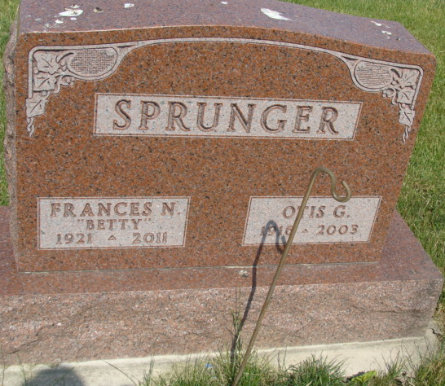
Photo by Alicia Kneuss

OTIS G. SPRUNGER, 86, of Berne, died Saturday, Aug. 2, 2003, at Swiss Village. Born Aug. 15, 1916, in Adams County, he was a retired farmer and served on the board of directors of Swiss Heritage Village. He was also a member of First Mennonite Church, Berne. Survivors include his wife, Frances "Betty" (Meyers); a daughter, Alice (Marian) Krehbiel of Pretty Prairie, Kan.; sons, Judson E. (Margaret) Sprunger of Berne, Jay C. (Gloria) Sprunger of Berne, Clifton L. (Susan) Sprunger of Berne, Arnold C. (Janet) Sprunger of St. Louis, Mo., and Douglas L. (Dianne) Sprunger of Muncie; sisters, Mrs. Berneta (Don) Yager of Berne, Doras Sprunger of Fort Wayne, and Margaret Eggers of Logansport; brothers, Merlin K. Sprunger of Berne, Vernon Sprunger of Cincinnati, Ohio, and Freadus Sprunger of Berne; 14 grandchildren and one great-grandchild. He was preceded in death by his parents, Jonas and Zilla (Gilliam) Sprunger. Service is 10 a.m. Tuesday at First Mennonite Church, Berne, with Rev. Robert Liechty and Rev. Curt Claassen officiating. Committal Service is 9 a.m. Tuesday at M.R.E. Cemetery, Berne. Calling is from 2 to 8 p.m. today at Swiss Village Chapel, Berne. Burial at M.R.E. Cemetery. Memorials to First Mennonite Church Missions or Swiss Village. Arrangements by Yager-Kirchhofer Funeral Home, Berne.

News-Sentinel, The (Allen County, Indiana)
August 4, 2003

**
Otis G. Sprunger, 86, of Berne, died at Swiss Village at 9:20 a.m. Saturday. He was born on August 15, 1916, in Adams County to Jonas and Zilla Gilliom Sprunger and married Frances "Betty" Myers on February 29, 1940; she survives. He was a retired farmer and a former member of the board of directors at Swiss Village. He was a member of First Mennonite Church of Berne. Other survivors are a daughter, Mrs. Marion (Alice) Krehbiel of Pretty Prarie, Kansas; five sons, Judson E., Jay C., and Clifton L. Sprunger, all of Berne; Arnold G. Sprunger of St. Louis, Missouri; and Douglas L. Sprunger of Cincinnati, Ohio; three sisters: Doras Sprunger of Fort Wayne, Mrs. Don (Berneta) Yager of Berne, and Margaret Eggers of Logansport; 14 grandchildren; and a great-grandchild. Two brothers are deceased. Funeral services will be held at 10 a.m. Tuesday in First Mennonite Church, but there will be a committal service at 9 a.m. Tuesday in MRE Cemetery, rural Berne. Visiting hours are 2 to 8 p.m. today in Yager-Kirchhofer Funeral Home, Berne. Preferred memorials are to First Mennonite Church and/or to Swiss Village.

Decatur Daily Democrat, Adams County, Indiana
Monday, August 4, 2003

