Oswin Sprunger
May 20, 18875 – December 31, 1949

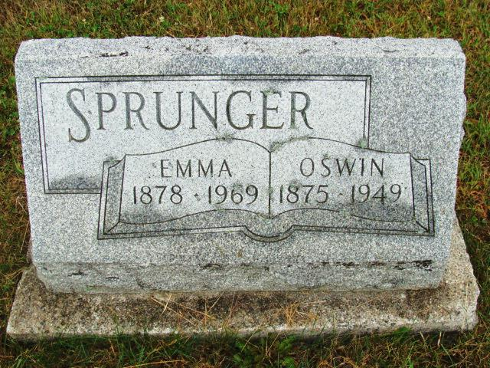
Photo by Alicia Kneuss

Handwritten-Wed. Jan. 4, 1950

FUNERAL HELD ON MONDAY FOR OSWIN SPRUNGER
74-Year-Old Local Man Dies Saturday Night After Long Illness

Funeral services were held at 2 p.m. Monday at the First Mennonite Church for Oswin Sprunger, 74, well-known local man who died at his home on Franklin Street at 9:20 p.m. Saturday. Rev. Olin A. Krehbiel officiated at the service and burial was in the M.R.E. Cemetery.
Mr. Sprunger's death was caused by arthritis and complications. He had ailed two years and was bedfast 11 months. He suffered very severely during much of his illness and especially in the latter stages. He had been in critical condition for several weeks.
Sprunger was engaged in the ice and ice cream business here for some time, then was custodian at the Berne Auditorium for many years. During the last war he was employed at the Decatur plant of the General Electric Company, then was night man at the Smith Brothers Furniture Factory until he was forced to quit because of health.
Sprunger was born in French Township, May, 20, 1875, the son of Rev. S. F. and Katherine Luginbill Sprunger. He was married to Emma Bracker on December 22, 1904, by the late Rev. J. W. Kliewer.
Surviving are the widow; a son, Ivan Sprunger, Seymour; a daughter, Mrs. Paul (Eva May) Clayton, Fort Wayne, and the following brothers and sisters: Ben F. Sprunger, Portland, Gustav Sprunger, Whittier, Calif.; Mrs. Dora Baumgartner, Altadena, Calif.; Mrs. Hulda Yoder, Los Angeles; Mrs. O. A. Talle, Pasadena, Calif.; the Misses Dorcas and Eva Sprunger, Berne; and Mrs. Homer Stahley, Fort Wayne.

A son, preceded in infancy and a sister, Minnie, died a few years ago.

Mr. Sprunger was a member of the First Mennonite Church and a resident of this community all his life.

Adams County, Indiana, Historical Museum
Oct1949-Feb1950 Scrapbook, Image 93

