Oswald O. Sprunger
December 1, 1884 – August 1, 1961

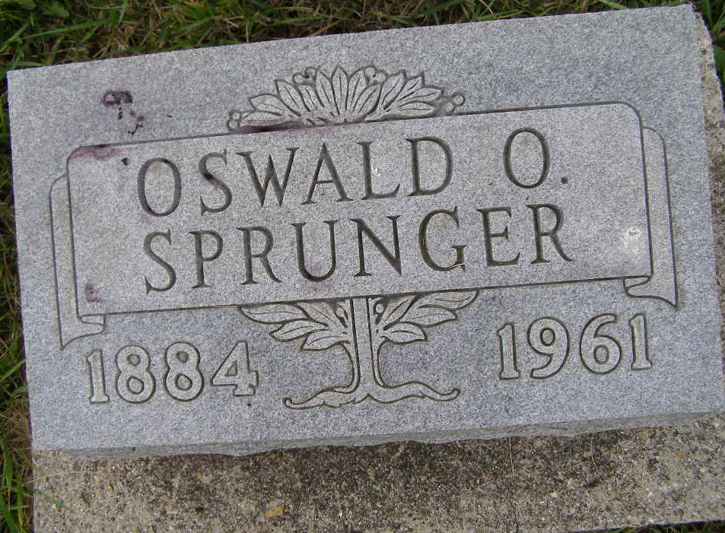
Photo by Shaunda Bedwell Opdycke

Oswald O. Sprunger Dies This Morning
Oswald O. Sprunger, 76, well known retired piano tuner of Berne, died at 6:15 o'clock this morning at the South View Rest Home at Bluffton. He had been bedfast for the past three years. Born in Adams County Dec. 1, 1884, he was a son of Christian C. and Rosanna Reusser-Sprunger, and had never married.
Mr. Sprunger attended Western College. For many years he was employed as a piano tuner in Fort Wayne, and Van Wert, O.
Surviving are three sisters, Mrs. A. J. (Bess) Neuenschwander of Berne, Mrs. Rene Reusser of Columbiana, O., and Mrs. M. A. (Gertrude) Thomas of Union City, and three brothers, B. Franklin Sprunger and Victor P. Sprunger, both of Berne, and Paul E. Sprunger of Milwaukee, Wis. One brother and one sister are deceased.
Funeral services will be held at 10 a.m. Thursday at the Yager Funeral Home in Berne, with burial in the MRE Cemetery. Friends may call at the funeral home after 1 p.m. Wednesday.
Adams County, Indiana Historical Museum
1951Jan-Aug1962 Scrapbook; image 35
Handwritten-Tuesday Aug. 1, 1961

