Osie Lenora (Heistand) Sprunger
May 8, 1908 – April 3, 2003

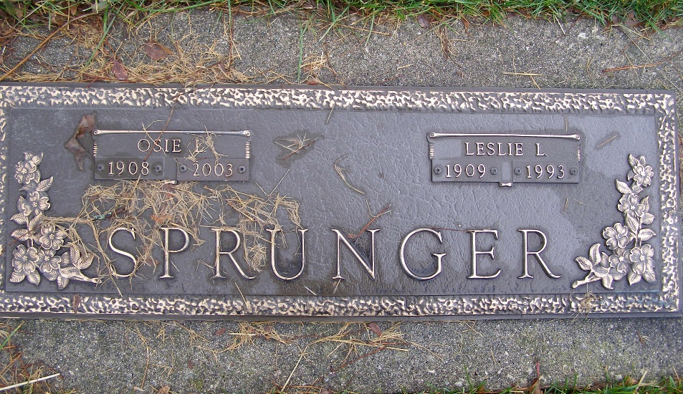
Photo by Shaunda Bedwell Opdycke

Osie L. Sprunger, 94, of Berne, a former elementary school teacher, died Thursday, April 3, 2003, at Swiss Village. The Adams County native was also a homemaker and member of First Missionary Church. She was a charter member of Berne Mother's Club, Sunday schoolteacher for several years and also served on the church Hospitality Committee. Surviving are sons Jerry L. of Berne and Jimmie of Pandora, Ohio; a daughter, Janean Moser of Berne; 12 grandchildren; and 20 great-grandchildren. She was preceded in death by her husband, Leslie L., and a brother, Ernest Hiestand. Services are 10 a.m. Monday at Swiss Village Chapel, Berne, with calling one hour before services. Calling is also from 2 to 8 p.m. Sunday at the chapel. Burial will be at MRE Cemetery, Berne. Memorials are to Swiss Village Endowment Fund. Information provided by Yager-Kirchhofer Funeral Home, Berne, 1-260-589-3101.

News-Sentinel, The (Allen County, Indiana)
Saturday, April 5, 2003
**

Indiana, U.S., Marriages, 1810-2001

Name Osie L Sprunger
[Osie L Hiestand]
Gender Female
Race White
Marital Status Widowed
Age 94
Birth Date 8 May 1908
Birth Place Adams County
Death Date 3 Apr 2003
Death Place Berne, Adams, Indiana, USA
Death Registration Date 2003
Father Frank Hiestand
Mother Maggie Fogle
Informant Jenean Moser, daughter
Burial 4/7/2003 M.R.E.

