Oscar Sprunger
October 2, 1890 – February 12, 1984

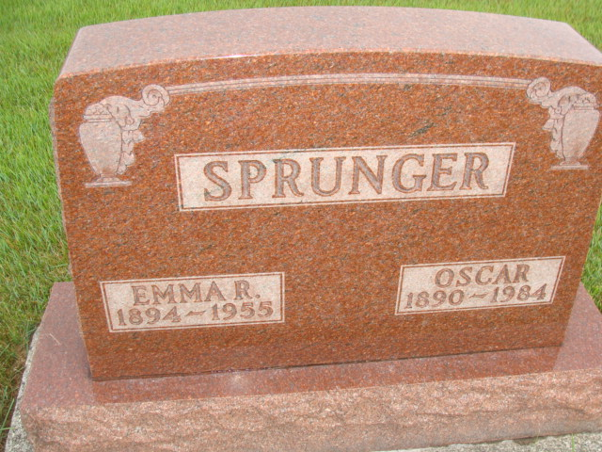
Photo by Alicia Kneuss

Indiana, U.S., Death Certificates, 1899-2017

Name Oscar Sprunger
Gender Male
Race White
Marital Status Widowed
Age 93
Birth Date 2 Oct 1890
Birth Place Indiana
Death Date 12 Feb 1984
Death Place Decatur, Adams, Indiana, USA
Death Registration Date 1984
Father Ulrich Sprunger
Mother Anna Liechty
Informant Omer Sprunger, son
Burial M.R.E. Cemetery 2/14/1984
**

Oscar Sprunger from tree Isaac Depew

Birth 2 Oct 1890 Indiana, USA
Residence 1930 Monroe City, Adams, Indiana, USA
Marriage 19 Feb 1957 Parma, New Madrid, Missouri, USA
Death 12 Feb 1984 Berne, Adams, Indiana, USA
Father Ulrich C Sprunger (1860-1932)
Mother Anna Liechty (1861-1945)
Spouse Emma R Hofstetter (1894-1955)
Spouse Leah A Nussbaum (1900-1963)
38097 People 6 Records 10 Sources

