Ornell P. Sprunger
August 28, 1920 – October 30, 2006

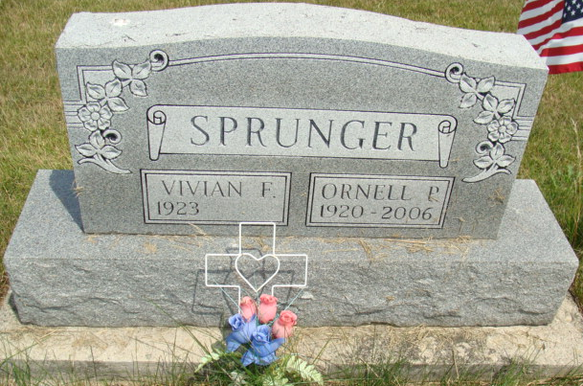
Photo by Alicia Kneuss

ORNELL P. SPRUNGER, 86, of Berne, died Monday, Oct. 30, 2006, 9:45 p.m., at his residence, in Swiss Village. He retired from Berne Furniture Supervisor of the Cushion Dept. for 46 years.
Surviving are his wife, Vivian (Gottschalk); daughter, Myrna (Ladd) Wheeler of Crofton, Md.; son, Ted D. (Pat) Sprunger of Fort Wayne; daughter, Betty A. Sprunger of Peru; son, Bob (Sara) Sprunger of Berne; sister, Irene Roin Mason of Mason, Ohio; eight grandchildren; and seven great-grandchildren.
Funeral service is 2:30 p.m. Thursday at First Missionary Church, with visitation one hour prior. The Rev. Kris McPherson officiating. Visitation also from 2 to 8 p.m. today at Yager-Kirchhofer Funeral Home, Berne. Burial in M.R.E. Cemetery with Military Rites by Berne Post 468. Memorials to Church Missions and World Team Mickey-Cherie Counter.

News-Sentinel, The (Allen County, Indiana)
Wednesday, November 1, 2006
**

Indiana, U.S., Death Certificates, 1899-2017

Name Ornell P Sprunger
Gender Male
Race White
Marital Status Married
Age 86
Birth Date 28 Aug 1920
Birth Place Adams County
Death Date 30 Oct 2006
Death Place Berne, Adams, Indiana, USA
Father Leonard Sprunger
Mother Ellen Lehman
Spouse Vivian (Gottschalk) Sprunger, informant
Burial 11/2/2006 M.R.E.

