Orlando Welty Sprunger
October 20, 1921 – March 31, 2022
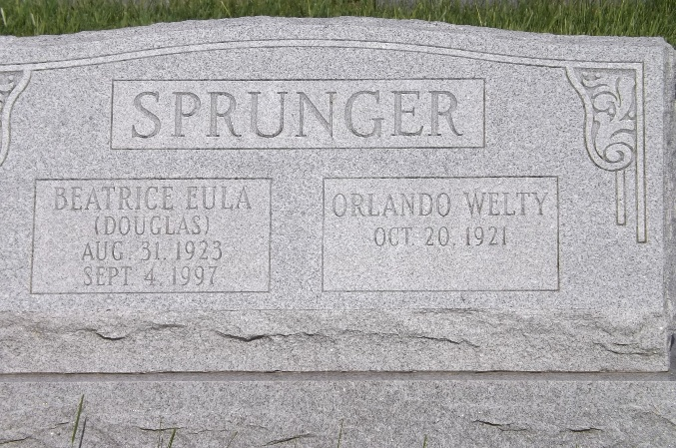
Photo by Jim Allen

Orlando W. Sprunger, 100, of Berne passed away Thursday March 31, 2022. He was born October 20, 1921, to Albert N. and Elma O. (Welty) Sprunger. He was married September 8, 1946, to Beatrice “Eula” Douglas.
He was a member of the First Mennonite Church in Berne. He retired from Berne Furniture in 1984. He volunteered for Et Cetera Ecke and the Mennonite Central Committee. He enjoyed traveling, camping and spending time with his family.
He is survived by three daughters, Marsha Sprunger of Columbus, Ohio; Elaine (Richard) Crider of Berne; and Faye (Cleo) Koop of Newton, Kansas; son, Bryan (Vicki) Sprunger of South Whitley; 11 grandchildren; and 16 great-grandchildren.
He was preceded in death by his parents; his wife; and five sisters.
Visitation will be Friday, April 8 from 4-7 p.m. and one hour prior to the 11 a.m. funeral service Saturday, April 9 at First Mennonite Church, 566 W. Main St., Berne.
Memorials may be made to Et Cetera Ecke, 152 W. Main St., Berne, IN 46711. Arrangements provided by Liechty Funeral Home in Berne.

The Berne Witness, Adams County, Indiana
April 6, 2022

