Orison James Sprunger
October 28, 1917 – September 29, 1996

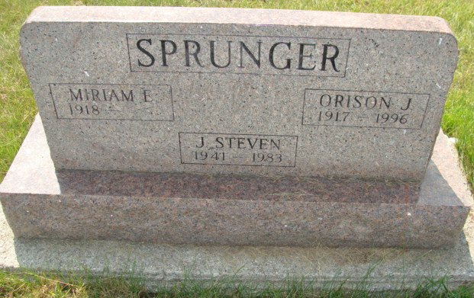
Photo by Alicia Kneuss

ORISON J. SPRUNGER, 78, of Berne died Sunday in Caylor-Nickel Medical Center. The Adams County native retired in 1983 from CTS Corp. in Berne after 18 1/2 years.
Surviving are his wife, Miriam; daughters, Jane Crau of Fort Wayne, Marcia Peters of Medina, Ohio, and June Sprunger of Berne; a son, Jeffrey of Tucson; brothers, Adrian of Bluffton, Rev. Vaughn of South Bend, Curtis of Mount Clements, Mich., and Fred of Siloam Springs, Ark.; nine grandchildren; and three great-grandchildren.
Services are 10:30 a.m. Wednesday in Grace Bible Church, Berne, with burial in MRE Cemetery. Calling is 2 to 5 and 6 to 8 p.m. Tuesday in Yager-Kirchhofer Funeral Home, Berne. Memorials are to the church.

News-Sentinel, The (Allen County, Indiana)
Monday, September 30, 1996

