Norma Agnes (Agler) Sprunger
August 29, 1914 – September 20, 2009

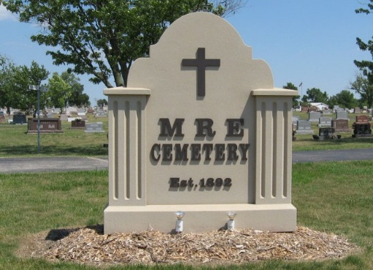
Photo by Tombstoner & Family

Norma A. Sprunger, 95, of Berne, Indiana passed away Sunday, September 20, 2009 at Chalet Village in Berne, Indiana. Norma was born on August 29, 1914 the daughter of Glen and Elva (Scoles) Agler, both deceased. She married Irwin E. Sprunger on April 30, 1936 and he preceded her in death in 1990.
Norma was a member of the Bethel Brethren Church in Berne, Indiana. She had been an employee of Winner House, Berco Inc., Liechty Foods, and Parkway Restaurant.
Norma is survived by a son, Lee W. (Sue) Sprunger of Berne, Indiana; a daughter, Eunice (John) Suman of Fairland, Indiana; eight grandchildren, Jay Sprunger, Jeff Sprunger, Joni Cincotta, Jessica Miller, Vanessa Kelly, Valerie Hopkins, Marla Thornton, and Melissa Price; three step-grandchildren, Trudi Diehm, Stacey Smyser, and Tim Suman; twenty great-grandchildren; and five step-great-grandchild-ren. Other survivors include a sister, Betty (Kenneth) Hawkins of Garrett, Indiana and a brother, Noel (Norma) Agler of North Fort Myers, Florida.
Norma was preceded in death by an infant daughter, Nancy in 1937; a daughter, Marylou Garlinger in 1989; two sisters, Thelma Liechty and Nolda Hendricks; two brothers, Donald Agler and Albert Agler; and a grandson, Jason Thornton in 1971.
A graveside service for family and friends will be held at 10:30 a.m. Wednesday, September 23, 2009 at the M.R.E. Cemetery of rural Berne, Indiana with the Rev. Joe Nass officiating. Family and friends will be received from 3:00 – 8:00 p.m. Tuesday, September 22, 2009 in the Yager-Kirchhofer Funeral Home in Berne. Preferred memorials are to Miracle Hill, South Carolina or the Bethel Brethren Church.

Yager-Kirchhofer Funeral Home, Adams County, Indiana

