Nellie C. (Jones) Sprunger
March 12, 1914 – December 14, 2003

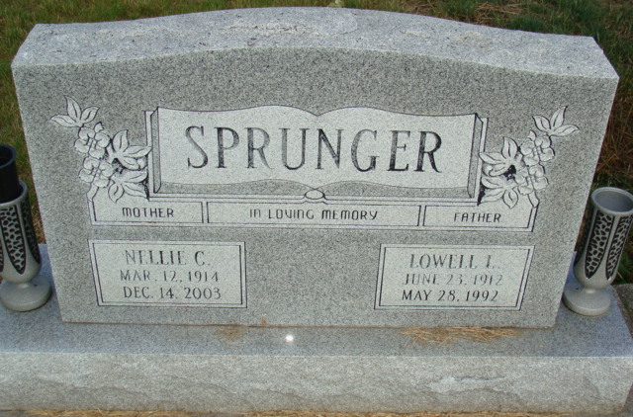
Photo by Alicia Kneuss

Nellie C. Sprunger, 89, of Berne, died on Sunday night in Lutheran Hospital, Fort Wayne. She was born on March 12, 1914 in Adams County to Charles and Ethel Siler Jones. She married Lowell Sprunger; he died in 1992.
She was a former employee of The Winner House and the Berco firm, both in Berne, and was a member of First Mennonite Church at Berne.
Surviving are three sons, Powell Sprunger of Celina, Ohio; Melville Sprunger of Phoenix, Arizona; and Michael Sprunger of Leamington, Utah; a brother, Ben Jones of Berne; three grandchildren; and two great-grandchildren. A daughter, a sister, and a brother are deceased.
Funeral services will be held at 11 a.m. Wednesday in Yager-Kirchhofer Funeral Home, Berne, with burial in MRE Cemetery, rural Berne. Visiting hours are 9-11 a.m. Wednesday. Preferred memorials are to the church.

Decatur Daily Democrat, Adams County, Indiana
Tues., Dec. 16, 2003

