Nathan Sprunger
February 1, 1875 – August 29, 1974

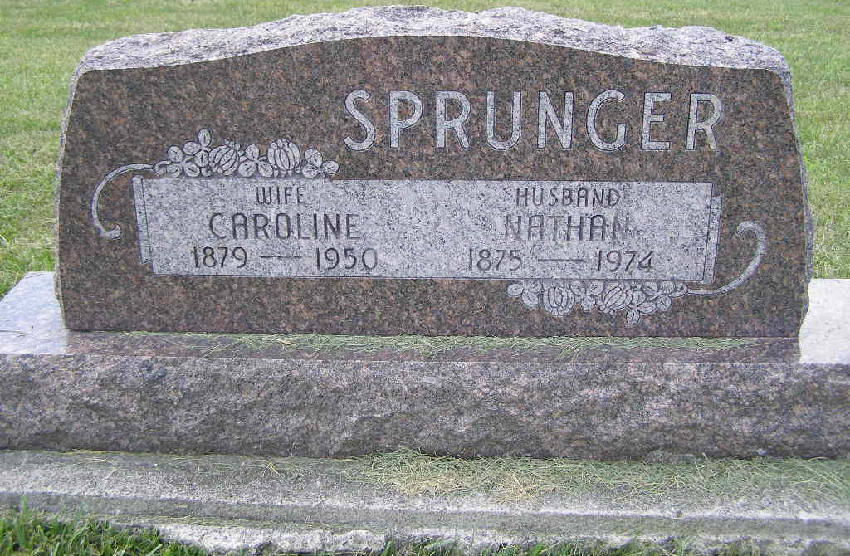
Photo by Shaunda Bedwell Opdycke

Nathan Sprunger, 99, oldest Berne resident dies at Swiss Village
Nathan Sprunger,99, of Swiss Village, Berne’s oldest resident, died at 3 p.m. Thursday at his residence. He had been in ill health one week. He was a member of the First Mennonite Church and a charter member of the men’s chorus. Mr. Sprunger was a retired farmer.
Born in Monroe township on Feb. 1, 1875, he was the son of Jacob and Anna Sprunger-Sprunger, and was married to Caroline Schedegger, who died in 1950. He married Martha Gilliom in 1953 and she died in 1970.
Surviving are eight children, Irvin of Geneva; Rolland of Indianapolis; Leslie of Berne; Vincent of Berne; Clyde of Berne; Mrs. Norval (Dorothy) Fuhrman of Decatur; Miss Jeanette Sprunger of Berne; Mrs. James (Lela) Miller of East Brunswick, N.J.; 22 grandchildren and 44 great-grandchildren. Three sons, seven sisters and four brothers preceded him in death.
Funeral services will be held at 2:30 p.m. Sunday at the Yager funeral home, with burial in the M.R.E. cemetery. Friends may call at the funeral home after 3 p.m. Saturday.

Decatur Daily Democrat, Adams County, Indiana
Friday Aug. 30 ,1974
**
Nathan Sprunger, Berne’s Oldest Resident Dies Thursday at 99
Nathan Sprunger, 99 Berne’s oldest resident, died at 3 p.m. Thursday at Swiss Village where he had made his home since 1968. Mr. Sprunger was a retired farmer and spent most of his life in this community.
He became ill one week ago and slept away peacefully, members of the family said. Until a week ago prospects that he would live to observe his 100th birthday appeared bright.
Mr. Sprunger was born February 1, 1875, in Monroe township, a son of Jacob and Anna Sprunger. He married Caroline Scheidegger in 1899 and she died in 1950. In 1953 Mr. Sprunger married Miss Martha Giddiom [sic] and she preceded in death in 1970.
Mr. Sprunger farmed for many years southeast of Berne, a short distance west of where Amishville, USA is now located. In addition to farming, he did some assessing work.
Surviving are eight children, Irvin, Geneva; Rolland, Indianapolis; Mrs. Dorothy Fuhrman, Decatur; Jeanette, Leslie, Vincent and Clyde, all of Berne and Mrs. James R. (Lila) Miller, East Brunswick, New Jersey. Three sons, Clarence, Festus and Reuben preceded in death at a young age. There are 22 grandchildren and 44 great-grandchildren.
Mrs. Sprunger was the last surviving member of a family of 12 children. Brothers and sisters who preceded in death were Leah, Mary, Martha, Silas, Jacob, Anna, Enoch, Ida, Miriam, Cornelius and Selma.
Mr. Sprunger was a member of the First Mennonite church and a charter member of the Mennonite Men’s Chorus.
Services will be held at 2:30 p.m. Sunday at the Yager Funeral Home, Rev. Vernon Sprunger, assisted by Rev .C.H. Wiederkehr will officiate. Friends may call at the funeral home after 3:00 p.m. on Saturday, August 31. Burial will be in the M.R.E. cemetery.

Burial Lot: Lot 123-Orig Platt
Date of Death: Aug. 29, 1974; Date of Burial: Sept. 1, 1974
Berne (IN) Library Heritage Room
1973-1984 MRE Obit Book, image # 63

