Naomi (Haecker) Sprunger
April 20, 1897 – November 29, 1994

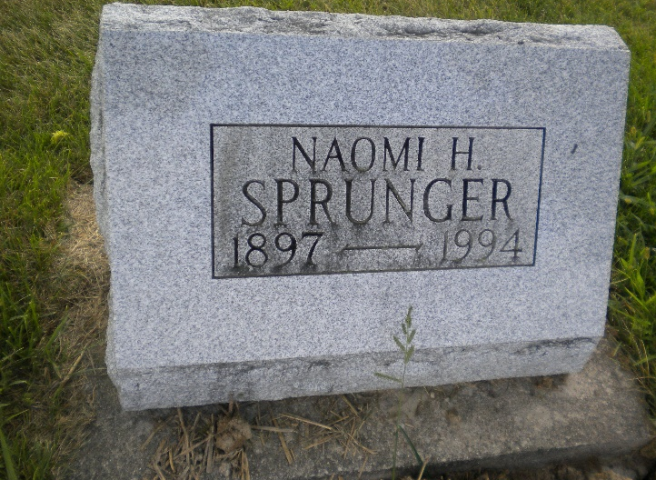
Photo by DSON1492

NAOMI HAECKER-SPRUNGER, 97, of Berne died Tuesday in Swiss Village. The Berne native was former nurse for Oberlin College, Oberlin, Ohio, and widow of Clifton "Wifty," who died in 1952.
Surviving is a daughter, Barbara A. Sprunger of Berne.
Memorial services are 2 p.m. Saturday in First Mennonite Church, Berne, where friends will be received following the service until 4 p.m. Graveside services are 1:15 p.m. Saturday in MRE Cemetery, Berne. Arrangements are by Yager-Kirchhhofer Funeral Home, Berne.
Preferred memorials are gifts to the Mennonite Commission of Overseas Missions, Bluffton College or Mennonite Central Committee.

News-Sentinel, The (Allen County, Indiana)
Thursday, December 1, 1994

