Nancy Kay Sprunger
February 10, 1937 – February 11, 1937

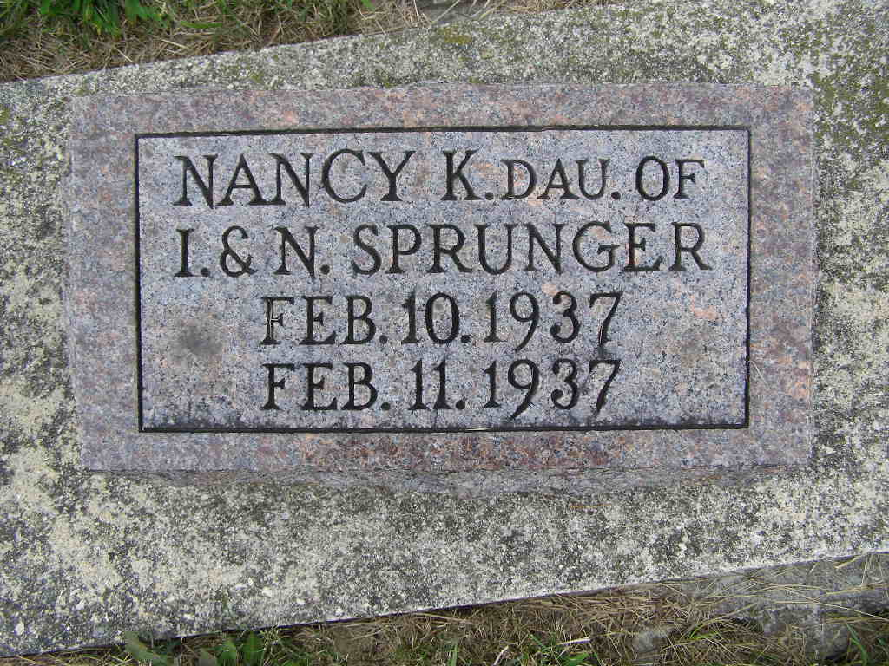
Photo by Shaunda Bedwell Opdycke

Indiana, U.S., Birth Certificates, 1907-1940

Name: Nancy Kay Sprunger
Gender: Female
Birth Date: 10 Feb 1937
Birth Place: Monroe, Adams, Indiana, USA
Registration Year: 1937
Father: Irvin Sprunger
Mother: Norma Agler
Certificate Number: 4555
Roll Number: 002
Agency: INDIANA STATE BOARD OF HEALTH
Volume Range: 6 – 10
**
Indiana, U.S., Death Certificates, 1899-2011

Name: Nancy K Springer
Gender: Female
Race: White
Age: 0
Marital status: Single
Birth Date: 10 Feb 1937
Birth Place: Indiana
Death Date: 11 Feb 1937
Death Place: Monroe, Adams, Indiana, USA
Father: Irwin Springer
Mother: Norma Springer

