Nancy Sprunger
August 27, 1945 – April 7, 1999

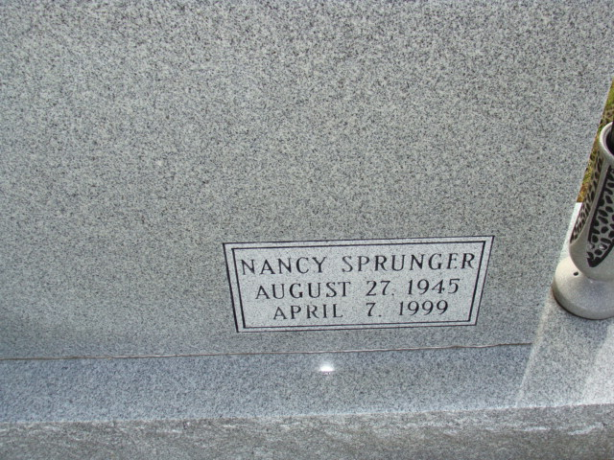
Photo by Alicia Kneuss

NANCY SPRUNGER, 53, of Celina, died Wednesday at Shane Hill Nursing Home. Born in Decatur, Ind., she worked at the Winner House in Berne, Ind. Surviving are her mother, Nellie Sprunger of Celina; and three brothers, Powell of Chicago, Melville of Phoenix and Michael of Leamington, Utah. Graveside services at 1 p.m. EDT (noon Fort Wayne time) Friday at Mennonite Reform Evangelical Cemetery, Berne. No calling. Arrangements by Ketcham-Ripley Funeral Home, Rockford.

Journal Gazette, The (Allen County, Indiana)
Thursday, April 8, 1999
**

NANCY SPRUNGER, 53, died at 3:25 a.m. April 7, 1999, at Shane Hill Nursing Home, Rockford. She was born Aug. 27, 1945, in Decatur, Ind., to Lowell and Nellie Jones Sprunger. Her mother survives in Celina.
Miss Sprunger worked at Winner House, Berne, Ind. She was a member of the Mennonite Church, Berne, Ind. She was active in the music department.
Survivors also include three brothers, Powell Sprunger of Chicago, Melville Sprunger of Phoenix and Michael Sprunger of Leamington, Utah; and several nieces and nephews.
Graveside services will begin at 1 p.m. Friday at the Mennonite Reform Evangelical Cemetery, Berne, Ind. Arrangements by Ketcham-Ripley Funeral Home, Rockford.

The Lima News, Allen County, Ohio
Thursday, April 8, 1999, p. B2, Col. 2

