Nan Marie (Eckrote) Sprunger
February 13, 1900 – September 28, 1989

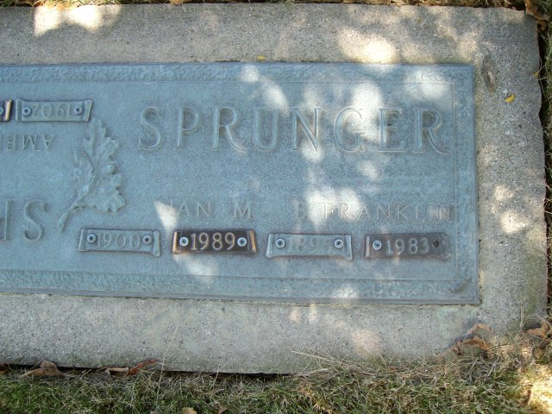
Photo by smalltown

Nan Marie Sprunger, 89, Swiss Village, died Thursday, at 7:05 pm at Swiss Village of a heart ailment. She had been ill for three months. Born Feb 13, 1900 in Adams County, (IN) to Harve Eckrote and Emma Sales-Eckrote, she married B. Franklin in 1917; he preceded in death in 1983. She was active in the Women's Missionary Society, and a member of First Mennonite Church.
She is survived by sons Roger Lee Sprunger, Berne, Jethro B. Sprunger, Decatur, and Donald F. Sprunger, Sweetwater, TN. Sisters (*should be daughters), Mrs. Richard B. (Gretchen) Lehman, Pandora OH, and Mrs. Merlin (Delores) Habegger, Palatine, IL; 16 grandchild-ren and 37 great-grandchildren. Preceding in death were Derryl B. Sprunger; four brothers and six sisters.
Calling is Sunday, 2-9pm and Monday 8-9 am at Yager-Kirchhofer Funeral Home and 9:30 to time of services at 10:30 am Monday, at First Mennonite Church. Rev. Curt Claassen will officiate with burial in MRE Cemetery. Memorials are to Swiss Village or First Mennonite Church.

Unknown newspaper clipping
Friday, September 29, 1989

