Viola Lorine (Schlatter) Sprunger-Moser
March 11, 1904 – August 24, 1996

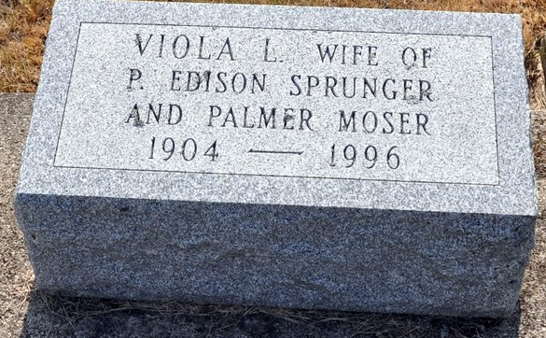
Photo by Deb Curry

Viola L. Moser, 92, of Swiss Village, Berne, Ind., died Aug. 24, 1996, at Adams County Memorial Hospital in Decatur of congestive heart failure.
She was born near Leo on March 11, 1904, to Jonas and Anna Neuhauser Schlatter. She married Edison Sprunger, who died in 1942. In 1955 she married Palmer Moser who died in 1972. She was the mother of Benjamin Sprunger, president f Mennonite Economic Development Associates and past president of Bluffton College.
Viola was co-owner of Sprunger Shoes in Berne from 1942 to 1992. She was a member of First Mennonite Church of Berne, a member and past president of Women in Missions and a member of the Berne Garden Club. She helped start the Nursery Sunday School Class in 1946 and taught for many years.
Surviving are two sons, Kenyon L. of Berne and Benjamin E. of Worthington, Ohio; a stepson, Millard Moser of Berne; two stepdaughters, Mary Eicher of Berne and Marjorie Baum of Bloomington, Ill.; 16 grandchildren and 22 great-grandchildren. A son, Stanley Keith, preceded her in death.
Services were held Aug. 27 at the First Mennonite Chapel. Burial was in the M.R.E. cemetery.

Mennonite Weekly Review, Newton, Kansas
August 12, 1999

