Miriam E. (Yeoman) Sprunger
July 4, 1911 – March 28, 1998

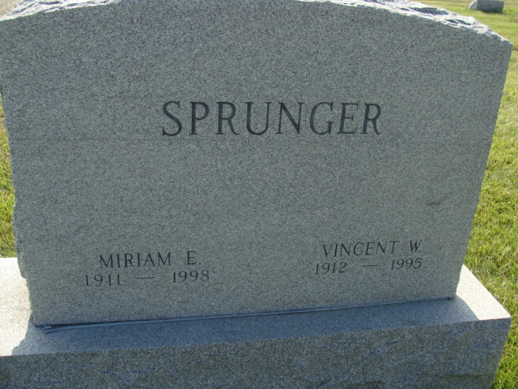
Photo by Alicia Kneuss

MIRIAM SPRUNGER, 86, died Saturday at Swiss Village in Berne. Born in Adams County, Monroe Township, she was a homemaker. She was also a former employee of the Economy Printing Co. in Berne. Her husband, Vincent W., preceded her in death. Surviving are five sons, Garth of Athens, Mich., Steven of Nappanee, Michael and Eric E., both of Berne and Jared of Fort Wayne; three daughters, Kae Linnet Sprunger and Alice Coblentz, both of Berne and Rebecca Sprunger of New York City; 13 grandchildren; and seven great-grandchildren. Services at 2 p.m. Wednesday at First Missionary Church, Berne. Calling from 2 to 8 p.m. Tuesday and from 9 to 12:30 p.m. Wednesday at Yager-Kirchhofer Funeral Home, Berne and an hour before services at the church. Burial in M.R.E. Cemetery, Berne. Memorials to the church.

Journal Gazette, The (Allen County, Indiana)
Sunday, March 29, 1998
**

Indiana, U.S., Death Certificates, 1899-2017

Name Miriam Sprunger [Miriam Yeoman]
Gender Female; Race White; Marital Status Widowed; Age 86
Birth Date 4 Jul 1911
Birth Place Adams County
Death Date 28 Mar 1998
Death Place Berne, Adams, Indiana, USA
Father John Yeoman
Mother Mary Etta Snider
Informant Kae Linnet Sprunger; daughter; Berne, Indiana
Burial April 1, 1998; MRE Cemetery; Berne, Indiana

