Miriam E. (Liechty) Sprunger
June 1, 1918 – September 9, 2020

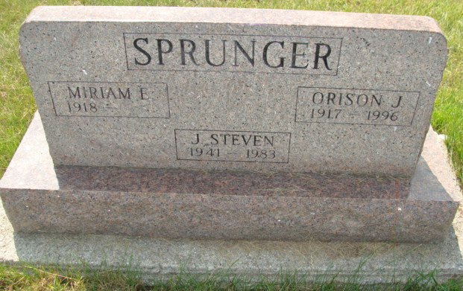
Photo by Alicia Kneuss

Miriam E. (Liechty) Sprunger, 102, of Berne, Indiana, was ushered into the presence of her Lord & Savior Jesus Christ on September 9, 2020 at Swiss Village. She was born on June 1, 1918 in Berne, Indiana to Jerry and Emma (Mosser) Liechty. Miriam married Orison J. Sprunger on June 16, 1940 and he preceded her in death on September 29, 1996.
After raising her five children, she worked for many years at Economy Printing Concern and the Berne Furniture Co. of Berne. She was a member of Grace Bible Church in Berne and had been in the church choir.
Some of her interests were card making and quilting. After Miriam retired, she hand quilted a bedspread for each of her children and grandchildren. She also made many baby quilts and wall hangings. We appreciate her dedication to her family and will miss her many prayers for each one, as well as her wonderful sense of humor.
Miriam is survived by her daughter-in-law Donna (Sprunger) Madar of Ramsey, NJ; children, Janis (Robert) Grau of Fort Wayne, IN, Marcia (David) Peters of Medina, OH, June (Duane) Sprunger of Berne, IN; and Jeff (Rhonda) Sprunger of Tucson, AZ; nine grandchildren, Stephanie (Bob) Spaulding, Karl (Gretchen) Grau, Beth (Mike) Carpenter, Kurt (Dede) Grau, LaChelle (Dan) Rickett, Matt (Nicole) Peters, Shannon (Jim) Gause, Rochelle (Eric) Criss, Landon (Cari) Sprunger; 19 great grandchildren; a sister, Anna Barbara Neuenschwander of San Antonio, TX; sisters-in-law, Arlene Sprunger of Berne, IN and Nyla Sprunger of Mt. Clemens, MI; and many nieces and nephews.
In addition to her husband, she was preceded in death by her son, J. Steven Sprunger in 1983; granddaughter, Jodi Sprunger in 1989; three brothers and five sisters.
The family would like to thank the employees of Swiss Village for their loving care, especially in recent months.
A graveside service will be held at 12 noon on Saturday, September 12, 2020 at MRE Cemetery in Berne with Pastor Jeff Gaskill officiating. Due to COVID-19, there will be no visitation. In lieu of flowers, memorial contributions may be made to Swiss Village Samaritan fund or Grace Bible Church missions, if you so desire.

Zwick & Jahn Funeral Home, Adams County, Indiana
September 10, 2020

