Wilhelmine “Minnie” Sprunger
July 18, 1873 – May 13, 1945

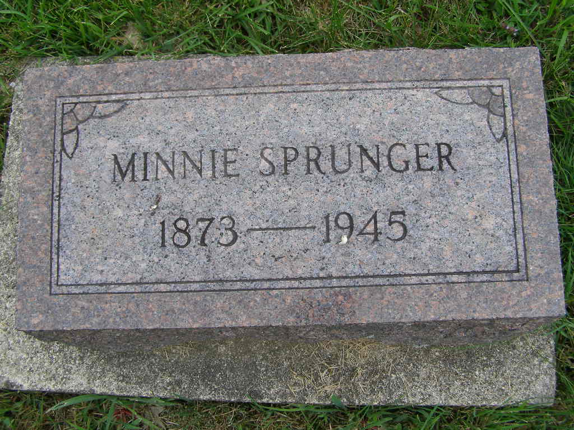
Photo by Shaunda Bedwell Opdycke

MINNIE SPRUNGER RITES HERE ON TUES. AFTERNOON
Daughter of Aged Mrs. S. F. Sprunger Dies at Home of Brother
Heart Ailment

Miss Wilhelmine (Minnie) Sprunger, 71, daughter of Mrs. S. F. Sprunger and the late Rev. S. F. Sprunger, passed away Sunday morning at 6 o’clock at the home of her brother Ben in Portland. Death was caused by a heart ailment with which she was suffering for several years.
Miss Sprunger spent more than forty years of her life in California and most of those years in Pasadena, where she was engaged as a saleslady and part of that time a children’s nurse. When her health began to fail she returned here last July. Two weeks ago she went to Portland to be in the home of her brother, having planned to be there for about a month. Her condition became critical while there, terminating in her death. Much of the time since December 27, she was bedfast at the home of her aged mother here.
The decedent was born in French township on July 18, 1873, bringing her age to 71 years, 9 months and 21 days. She was a daughter of Rev. Samuel F. and Katherine Luginbill-Sprunger.
Surviving are her aged mother, who is 96, and three brothers and six sisters; Ben of Portland, Oswin of Berne, Gustav of Whittier, California; Mrs. Theodora Baumgartner and Mrs. Metta Talle oof Pasadena, Mrs. Hulda Yoder of Riverside, Calif., the Misses Dorcas and Eva Sprunger, Berne, and Mrs. Homer C. Staley, Fort Wayne.
The body was returned here to the Yager mortuary. Funeral services will be conducted at 2 p.m. Tuesday at the funeral home with the Rev. John P. Suderman officiating. Burial will be in the MRE Cemetery.

Adams County (IN) Historical Museum
1941a Jan-June Scrapbook, image 017
Handwritten-Mon. May 14, 1945

