Milo Sprunger
February 3, 1897 – June 26, 1980

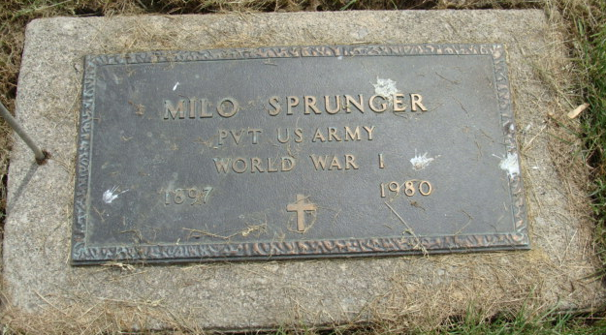
Photo by Alicia Kneuss

Indiana, U.S., Death Certificates, 1899-2017

Name Milo Sprunger
Gender Male
Race White
Marital Status Divorced
Age 83
Military yes
Birth Date 3 Feb 1897
Birth Place Indiana
Death Date 26 Jun 1980
Death Place Berne, Adams, Indiana, USA
Death Registration Date 1980
Father Silas Sprunger
Mother Rosina Reef
Informant Virgil Sprunger, Monroe, IN
Burial M.R.E. Cemetery 6/28/1980
**

Indiana, U.S., Marriage Certificates, 1960-2012

Name Milo Sprunger
Gender Male; Race White; Marriage Age 32
Birth Date 7 Feb 1897; Birth Place Berne, Indiana
Marriage License Date 6 Apr 1929
Marriage Date 7 Apr 1929; Marriage Place Allen, Indiana, USA
Residence Place Allen, Indiana
Father Silas Sprunger; Mother Rosia Reff
Spouse Alma Kurtz
Other Person Louis C Rippe
Officiator C L Wagner

