Millard Leroy Sprunger
November 14, 1908 – November 2, 1999

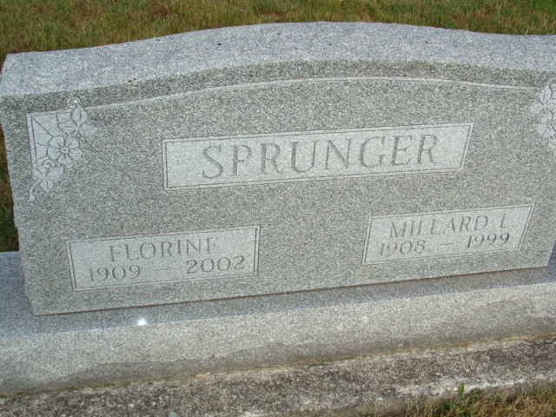
Photo by Alicia Kneuss

Millard L. Sprunger, 90, of Berne, a retired upholsterer, died Tuesday, Nov. 2, 1999, at Swiss Village. The Adams County native was retired from Dunbar Furniture after more than 35 years of service and was a member of Grace Bible Church, where he was former trustee. Surviving are his wife, Florine; a son, Lynn W. of Berne; daughters Arlene Huffman of Fort Wayne and Jean Sprunger of Berne; a brother, Raymond of Berne; sisters Helen Beer, Ada Marie Frank and Marjorie VonGunten, all of Berne; 11 grandchildren; and 13 great-grandchildren. He was preceded in death by a sister, Mary Ann Sprunger. Services are 10:30 a.m. Friday at Swiss Village Chapel, Berne, with calling from 9:30 a.m. until services and also from 3 to 8 p.m. today at the chapel. Burial will be in M.R.E. Cemetery. Memorials are to A.B.W.E. Missions or Native American Missions. Information provided by Yager-Kirchhofer Funeral Home, Berne, 1-219-589-3101.

News-Sentinel, The (Allen County, Indiana)
Thursday, November 4, 1999

