Milka Sprunger
December 9, 1882 – March 16, 1976

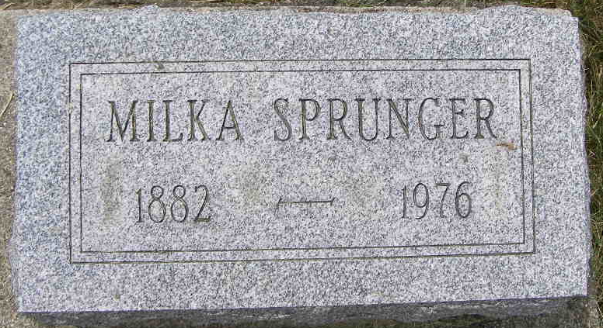
Photo by Shaunda Bedwell

Milka Sprunger
Services will be held at 3:30 p.m. Thursday at the Yager Funeral Home for Miss Milka Sprunger, 93, lifelong resident of this community who died at 4:45 a.m. Tuesday at Swiss Village. Rev. Kenneth G. Bauman will officiate at the service and burial will be in the M.R.E. Cemetery. Friends may call at the funeral home after 4 p.m. today. The 11:30 hour for the funeral is due to the many church activities associated with the Union Evangelistic Crusade this week.
Miss Sprunger had been bedfast several years and death is attributed to complications. She baked pastries of all kinds in her home for many years selling the products to the public.
She was born in Monroe Township, Adams County, December 9, 1882, a daughter of Frederic A. and Catherine Sprunger Sprunger.
Surviving is a sister-in-law, Mrs. Anna Sprunger of Swiss Village and nieces and nephews. She was the last surviving member of her family. Three brothers and seven sisters preceded in death.
Miss Sprunger was a member of the First Mennonite Church.
Berne Library Heritage Room
1973-1984 MRE Obit Book, Image #110

