Mildred Sprunger
June 4, 1895 – April 11, 1979

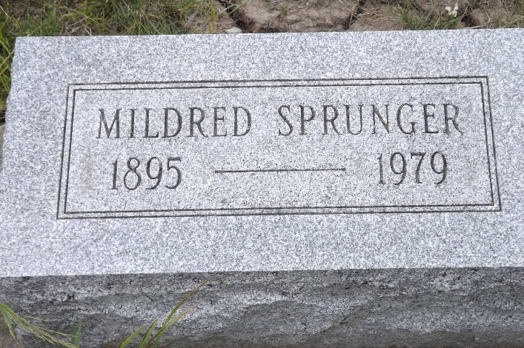
Photo by Jim Allen

Indiana, U.S., Death Certificates, 1899-2017

Name Mildred Sprunger
Gender Female
Race White
Marital Status Never Married (Single)
Age 83
Birth Date 4 Jun 1895
Birth Place Indiana
Death Date 11 Apr 1979
Death Place Bluffton, Wells, Indiana, USA
Death Registration Date 1979
Father Peter A. Sprunger
Mother Katherine
Informant Helen Habegger
Burial M.R.E. 4/14/1979
**

Mildred Sprunger from tree Wood Watkins Family Tree

Birth 4 Jun 1895 Indiana, USA
Residence 30 Apr 1940 Adams, Indiana, USA
Death 11 Apr 1979 Bluffton, Wells, Indiana, USA
Father Peter A Sprunger (1839-1895)
Mother Katherine Sprunger (1853-1938)
7597 People 9 Records 9 Sources

