Merlin William Sprunger
February 11, 1924 – April 25, 2011

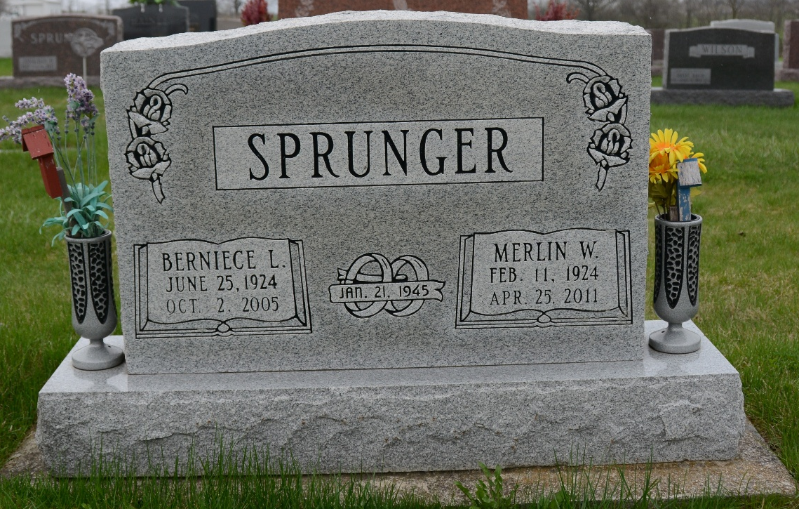
Photo by Deb Curry

Merlin W. Sprunger, 87, of Berne, died Monday, April 25, 2011, in Swiss Village Retirement Community. He was born in Adams County on February 11, 1924 to Joel and Clara Ellenberger Sprunger. Among survivors are a son, Ryan Sprunger of Berne, and three daughters: Mrs. Fred (Charlotte) Linn of Berne, Nancy Smith of Berne, and Mrs. Tom (Sharon) Ninde of Bluffton.
Funeral services will be held at 2 p.m. Thursday in First Mennonite Church at Berne, with burial in MRE Cemetery, rural Berne. Visiting hours are 2-8 p.m. Wednesday in the chapel at Swiss Village and 1-2 p.m. Thursday in the church. Funeral arrangements were by Yager-Kirchhofer Funeral Home, Berne.
Decatur Daily Democrat, Adams County, Indiana
April 26, 2011

