Meredith Levi Sprunger
October 11, 1928 – January 2, 1966

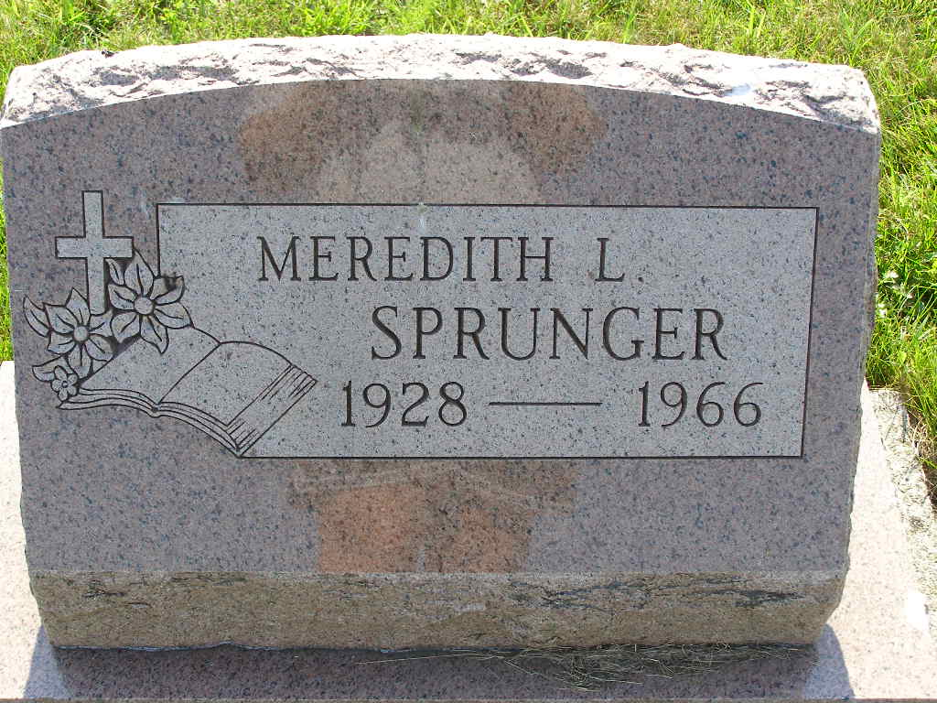
Photo by Shaunda Bedwell Opdycke

Services for Meredith L. Sprunger, 37, operator of a car leasing service, who died late Sunday at the Robert Long Hospital, Indianapolis, will be at the Yager Funeral Home. Calling after 2 pm Tuesday. The wife, Iris, and four sisters, including Mrs. Walter Eloranta, Fort Wayne, survive.

Journal-Gazette, Allen County, Indiana
January 3, 1966, p. 3A
**

Indiana, U.S., Birth Certificates, 1907-1944

Name Meridith Levi Sprunger
Gender Male
Birth Date 11 Oct 1928
Birth Place Berne, Adams, Indiana, USA
Father Harry Sprunger
Mother Frieda Neuhouser
Certificate Number 45660
Roll number 40474_357761
Volume Range 91 – 95
**

Meridith Levi Sprunger from tree Neuenschwander family tree

Birth 11 Oct 1928 Indiana, USA
Residence 1946 Berne, Adams, Indiana, USA
Death 2 Jan 1966 Indianapolis, Marion, Indiana, USA
Father Harry Sprunger (1894-1951)
Mother Frieda Neuhauser (Born 1897)
497 People 7 Records 7 Sources

