Menno Simeon Sprunger
April 13, 1890 – July 6, 1952

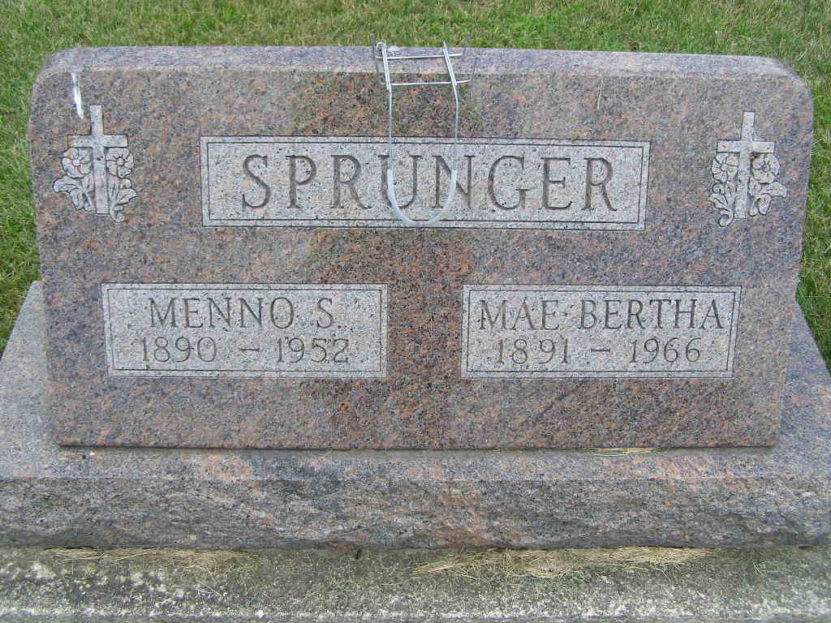
Photo by Alicia Kneuss

BRIEF ILLNESS PROVES FATAL TO MENNO SPRUNGER
Dies at Fort Wayne Hospital Last Night; Rites on Wednesday

Menno Simeon Sprunger, 62, well known Berne man residing at 317 East Water Street, died at 9:30 p.m. Sunday at St. Joseph's Hospital in Fort Wayne, following a brief illness. Mr. Sprunger was employed by the Adams County Highway Department.
According to an autopsy performed this morning on Mr. Sprunger's body, a blood clot on the brain was revealed. Cause of death will be announced by the Adams County coroner, Harmon Gillig, the Yager Funeral Home here was informed by attaches of the Fort Wayne Hospital, as there is a possibility that death may have resulted from a mishap while Mr. Sprunger was engaged in his regular duties with the County Highway Department. If this proved to be the case, the verdict will be one of accidental death. Death is said to have resulted from a cerebral hemorrhage.
Mr. Sprunger became ill Thursday morning. His right arm became paralyzed and Sunday morning additional parts of his body became affected. His condition became rapidly worse Sunday and at 5:25 p.m. Sunday, he was rushed to St. Joseph's Hospital, the trip being made by Yager ambulance. He was given specialists. He was taken to surgery for an exploratory operation but died during the operation.
An employee of the highway department (missing) injury last Wednesday while working under a bridge, he was accidentally struck under his left eye and nose, according to members of the family. He had complained (missing). Mr. Sprunger had been employed with the County Highway Department for the past 14 months. Prior to that he was with the State Highway Department and before that he had an egg route for the V. C. Graber Produce firm for many years. He was born April 13, 1890, in Monroe Township, the son of Simeon and Emma Huser Sprunger. He was married to Mae Stauffer, March 25, 1917.
Surviving are the widow and the following children: Weldon, Van Wert, Ohio; Leland and Loren, Berne; Mrs. Kenneth (Janice) Hoffman, Decatur Route 4; Mrs. James (Evelyn) Hart, Decatur Route 4; Paul and Areta, both at home. There are 11 grandchildren, two brothers, Philemon (missing); four half-brothers Gerhardt, Fort Wayne; Albert, Monticello; Simeon, Walkerton; Martin F., Decatur, and three half-sisters, Mrs. Herman Hirschy, Mrs. William Burry and Miss Elvina A. Sprunger, all of Berne. The parents, one brother, two sisters and one half-brother preceded in death.
Mr. Sprunger was a member of the Trinity E. U. B. Church where funeral services will be held Wednesday at 10 a.m. Rev. Karl Tauber, pastor of the church, will officiate with burial in the MRE Cemetery.

Adams County Historical Museum
1952May-March1955 Scrapbook, Image 26
Handwritten-Mon. July 7, 1952

