Max Truman Sprunger
April 13, 1921 – June 26, 2006

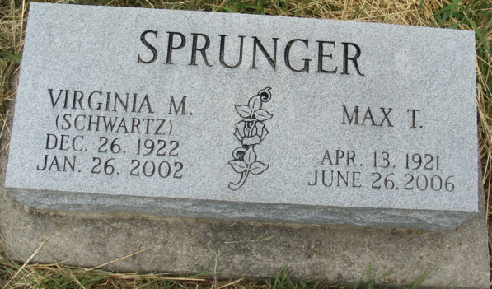
Photo by Alicia Kneuss

Max Truman Sprunger in the Lancaster, Pennsylvania, U.S., Mennonite Vital Records, 1750-2014

Name Max Truman Sprunger
Relationship Head
Birth Date 13 Apr 1921
Birth Place Berne, Indiana, USA
Marriage Date 26 Mar 1942
Death Date 26 Jun 2006
Death Place Goshen, Indiana, USA
Household Members (Name) Relationship
Max Truman Sprunger Head
Martin L. Sprunger Father
Linda C. Luginbill Mother
Virginia Mae Schwartz Spouse
Christian W. R. Schwartz Father-in-law
Minnie Sprunger Mother-in-law
**

U.S., Cemetery and Funeral Home Collection, 1847-Current

Name Max T. Sprunger
Gender Male
Death Age 85
Birth Date 1921
Birth Place Berne, Indiana
Marriage Date 26 Mar 1942
Marriage Place Berne, Indiana
Residence Place Goshen, Indiana
Death Date 26 Jun 2006
Parents Martin L. Sprunger; Linda C. Luginbill Sprunger
Spouse Virginia M. Schwartz
Children Edumund, Ann Sprunger, Joseph, Jonathan, Lewis
Siblings Opal Zuercher, Margaret Beitler

