Matilda Magdalena Sprunger
July 7, 1888 – December 24, 1929

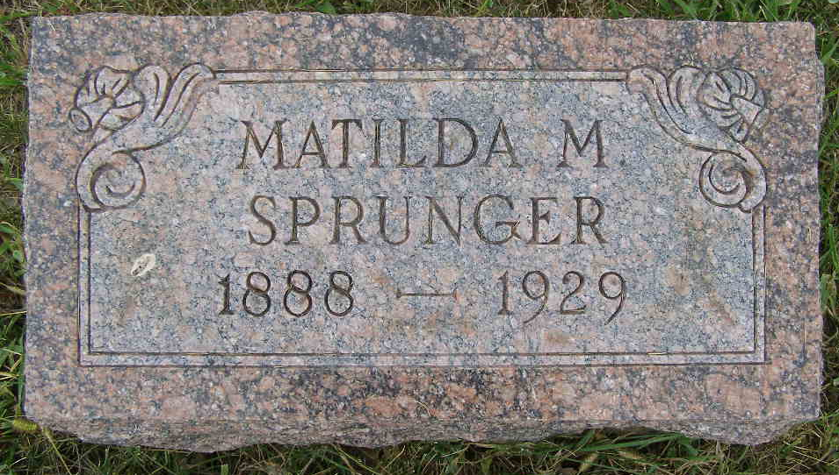
Photo by Shaunda Bedwell Opdycke

Indiana, U.S., Death Certificates, 1899-2017

Name Matilda M. Springer
Gender Female
Race White
Marital Status Single
Age 41y 5m 17d
Birth Date 7 Jul 1888
Birth Place Indiana
Death Date 24 Dec 1929
Death Place Monroe, Adams, Indiana, USA
Death Registration Date 1929
Father Simeon Sprunger, informant
Mother Emma Huser
Burial M. R. E. Cemet. 12-27-1929

