Mathilda Emma (Felber) Sprunger
July 16, 1901 – April 17, 1996

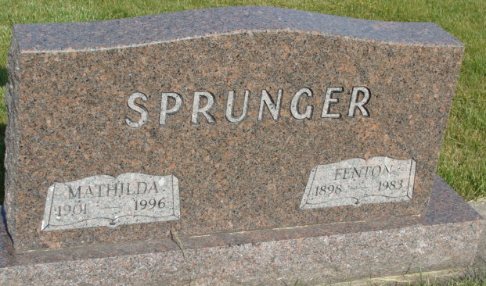
Photo by Alicia Kneuss

MATHILDA E. SPRUNGER, 94, of Berne died Wednesday in Swiss Village. The Adams County native was the widow of Fenton, who died in 1983. Surviving are daughters, Rosanna Wanner of Geneva and Christine Burch of Flat Rock, N.C.; sons, Virgil L. of Monroe, Donald W. of Berne and Joseph N. of Fort Wayne; sisters, Sarah Liechty of Berne, Esther Thomas of Portland and Elma Felber of Decatur; a half sister, Florene Coffel of Fort Wayne; a half brother, Harry Felber of Akron, Ohio; 12 grandchildren; 21 great-grandchild-ren; and three great-great-grandchildren. Services are 10 a.m. Saturday in Haggard & Armes Funeral Home, Decatur, where calling is 2 to 5 and 7 to 9 p.m. today. Burial will be in MRE Cemetery, Berne. Memorials are to Decatur Wesleyan Church.

News-Sentinel, The (Allen County, Indiana)
Friday, April 19, 1996

