Mathilda (Baumgartner) Sprunger
December 16, 1866 – March 8, 1953

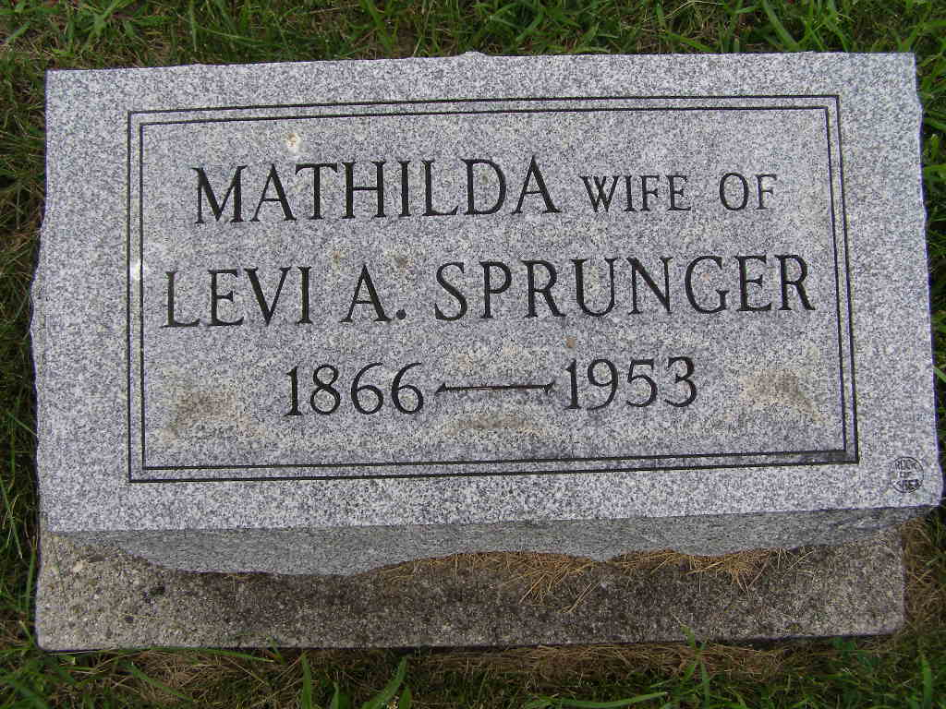
Photo by Shaunda Bedwell Opdycke

Indiana, U.S., Death Certificates, 1899-2017

Name Mathilda Sprunger
[Mathilda Baumgartner]
Gender Female
Race White
Marital Status Married
Age 86
Birth Date 16 Dec 1866
Birth Place French Township, Adams Co.
Death Date 8 Mar 1953
Death Place Berne, Adams, Indiana, USA
Death Registration Date 1953
Father Abraham Baumgartner
Mother Caroline Ellenberger
Informant not listed
Burial M.R.E. 3/9/1953

