Mary (Wanner) Sprunger
May 22, 1898 – April 13, 1981

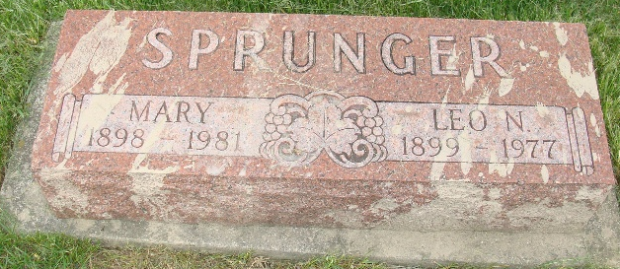
Photo by Alicia Kneuss

Indiana, U.S., Marriages, 1810-2001

Name Mary Warner
Gender Female
Race White
Age 23
Event Type Marriage Registration (Marriage)
Birth Date 27 Mar 1898
Birth Place Adams, Indiana
Marriage Date 5 Mar 1921
Marriage Place Indiana, United States
Residence Place Adams, Indiana
Father Emanuel Warner
Mother Solome Herschy
Spouse Leo Sprunger
Page 275
**

Mary Wanner from tree Morton

Birth 22 May 1898 Berne, Adams, Indiana, USA
Marriage 6 Mar 1921 Berne, Adams, Indiana, USA
Residence 1960 Fort Wayne, Allen, Indiana, USA
Death 13 Apr 1981 Fort Madison, Lee, Iowa, USA
Father Emanuel Warner (1864-1921)
Mother Salome M. Smith (1864-1956)
Spouse Leo Sprunger (1899-1977)
1761 People 9 Records 11 Sources

