Mary J. Sprunger
July 14, 1865 – December 26, 1938

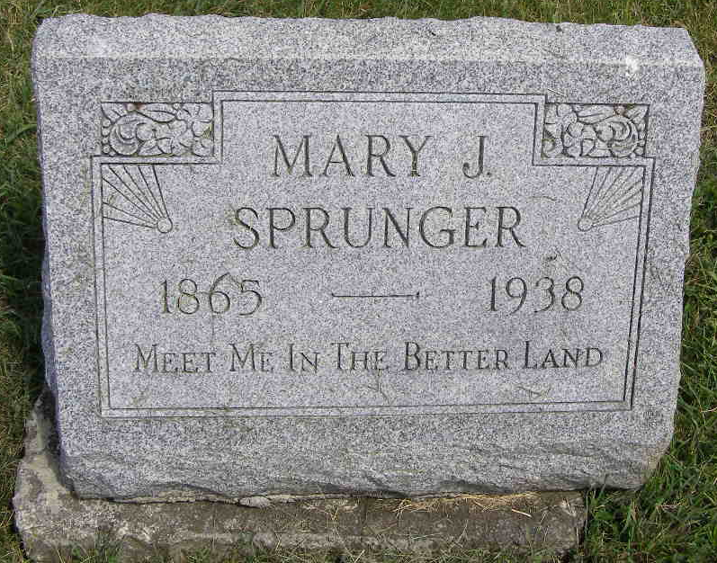
Photo by Shaunda Bedwell Opdycke

INJURIES FATAL TO FISHER LAD
Bluffton, Jan. 3 - Charles Fisher, 17, a member of the senior class at Petroleum high school and a member of the high school basketball team, died at the Wells county hospital here at 8:10 Friday morning, the second victim to succumb to injuries received in a collision at 3:30 p.m. Monday, Dec. 26, between automobiles driven by his father, Armor Fisher, near Petroleum, and Lee Wittwer of this city. A fractured skull and other injuries caused the death of the youth.
Miss Mary J. Sprunger, 73, of Berne, who was riding in the Wittwer machine, died shortly after the accident. Others injured in the collision are recovering, including Mrs. Fisher, who was riding with her husband and two sons, and Mrs. Selma Lannert of Monroe, riding in the Wittwer car, both of whom suffered broken legs.
The parents and a brother, Francis, 13, survive the youthful crash victim.

Unknown source
Handwritten date: Tuesday, 1939
**

Indiana, U.S., Death Certificates, 1899-2017

Name Mary J Sprunger
Gender Female
Race White
Marital Status Single
Age 73y 5m
Birth Date Jul 1865
Birth Place Berne Indiana
Death Date 26 Dec 1938
Death Place Bluffton, Wells, Indiana, USA
Cause of death Auto collision
Death Registration Date 1938
Father Jacob Sprunger b. Switzerland
Mother Anna Sprunger b. Switzerland
Informant Silas Sprunger, Berne, IN
Burial M.R.E. Cem. 12-29-1938
**

Mary J Sprunger from tree Julie Frederick Family Tree

Birth 14 Jul 1866 Berne, Adams, Indiana, USA
Residence 1930 Fort Wayne, Allen, Indiana, USA
Death 26 Dec 1938 Bluffton, Wells, Indiana, USA
Father Jacob Sprunger (1832-1903)
Mother Anna J Sprunger (1843-1918)
14197 People 7 Records 34 Sources

