Mary Aldine (Lehman) Sprunger
April 8, 1886 – July 7, 1961

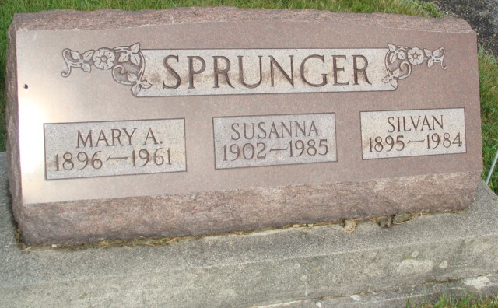
Photo by Alicia Kneuss

Indiana, U.S., Death Certificates, 1899-2017

Name Mrs Silvan (Mary) Sprunger
[Mrs Mary Sprunger]
[Silvan Lehman]
[Mary Sprunger]
Maiden Name Lehman
Gender Female
Race White
Marital Status Married
Age 65
Birth Date 8 Apr 1896
Birth Place Monroe Twp Adams Co., USA
Death Date 7 Jul 1961
Death Place Decatur, Adams, Indiana, USA
Death Registration Date 1961
Father David F Lehman
Mother Emma Sprunger
Spouse Silvan Sprunger, informant
Burial 7-10-1961 M.R.E.

