Mary Ann Sprunger
October 8, 1874 – November 1, 1959

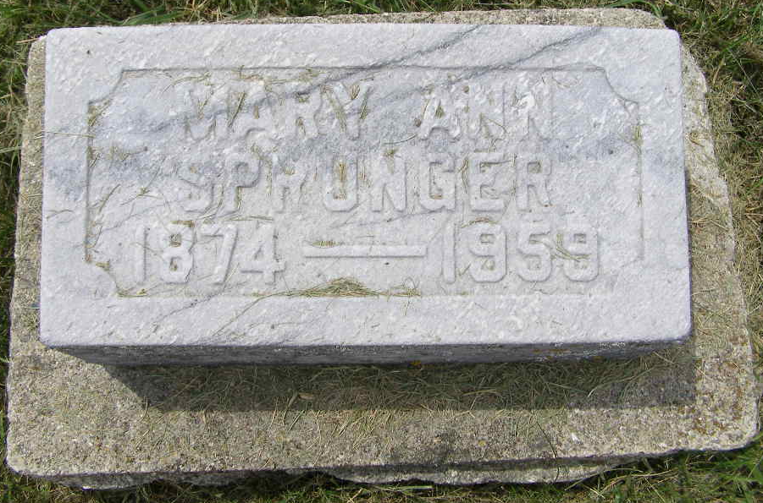
Photo by Shaunda Bedwell Opdycke

Indiana, U.S., Death Certificates, 1899-2017

Name Mary Ann Sprunger
Gender Female
Race White
Marital Status Never Married (Single)
Age 85
Birth Date 8 Oct 1874
Birth Place Indiana
Death Date 1 Nov 1959
Death Place Berne, Adams, Indiana, USA
Death Registration Date 1959
Father Frederick Sprunger
Mother Katherine Sprunger
Informant Miss Rose Sprunger, sister
Burial 11/3/1959 M. R. E. Cemetery
**

Marianna Sprunger from tree Claassen Family Tree

Birth 8 Oct 1874 Monroe City, Adams, Indiana, USA
Residence 1920 Adams, Indiana, USA
Death 1 Nov 1959 Berne, Adams, Indiana, USA
Father Friedrich A Sprunger (1849-1914)
Mother Katharina "Catherine" Sprunger (1854-1929)
1786 People 3 Records 4 Sources

