Mary Ann Sprunger
July 9, 1918 – July 20, 1918

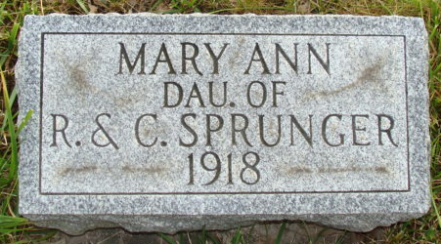
Photo by Alicia Kneuss

Indiana, U.S., Death Certificates, 1899-2017

Name Mary Anna Sprunger
Gender Female
Race White
Marital Status Single
Age 11d
Birth Date 9 Jul 1918
Birth Place Monroe, Indiana
Death Date 20 Jul 1918
Death Place Monroe, Adams, Indiana, USA
Death Registration Date 1918
Father Rufus Sprunger
Mother Cora Luginbill
Informant Rufus Lehmay, Monroe, IN
Burial M.R.E. Cem 7/21/1918

